CLIMATE DISASTERS & SEA-LEVEL RISE
This is a downloadable version of the "Global Warming" section of a website (www.kelly4senate.net) created by Pat Kelly, an environmental engineer and patent attorney who is running for the U.S. Senate, in Missouri.
​THROUGHOUT THE 2022 ELECTION CYCLE, VOTERS NEED TO ASK WELL-CRAFTED, FACT-BASED QUESTIONS ABOUT GLOBAL WARMING, OF EVERY CANDIDATE
To anyone who knows what is actually happening to our country (and the entire planet) as a result of global warming, climate change, and sea level rise, it is easy to become glum, and grim.
But that attitude does not, and will not, win elections, for candidates.
So, I’m going to propose a different approach, with a different attitude. One where anyone who wants to actually help the planet, help humanity, and make connections with other people who have good hearts, good sense, and goodwill, can approach the 2022 election cycle with a full, fair, and entirely true recognition that it offers a noble, challenging, and worthwhile quest, and adventure, for anyone who chooses to making a commitment to helping elect better (and, better-informed) candidates to both the House, AND the Senate. Here is the challenge, and the quest:
Working both:
(i) on your own – by doing your own reading, studying, preparing, rehearsing, and posting drafts on social media of what you are hoping and planning to do, before you actually do it; and,
(ii) in cooperation and communication with other like-minded, good-hearted, sincere people who truly want to try to help their friends, their families, and all of humanity,
please consider choosing, and committing to, the following challenges:
(A) try your absolute best, to figure out the best way to ask, and phrase, some carefully-loaded and pointed questions, which people who want to help slow down global warming can ask of any and all candidates for Congress; and,
(B) go out and actually start doing it, in public, at any and every event where any candidate for Congress will be appearing, and might be willing to answer questions from the audience after the `speechifying’ part of the event ends.
​ And, commit to doing it again and again, repeatedly, as an “iterative” process, where one of your main goals is to seriously question and analyze, as honestly as possible, what went right, what didn’t seem to work so well, and how YOU might be able to do better, next time, since YOU are the only person YOU can control. If you’re not already familiar with them, read the Wikipedia entries on Edwards Deming, Masaaki Imai, and “Continual improvement process”, and commit to making “always try to keep getting better” one of your personal goals, both in the challenge proposed herein, and in life in general.
​ And, learn to anticipate the responses you are likely to get, from politicians, when you ask them questions they do not want to have to answer. For numerous reasons, politicians will try to sidestep, deflect, and dance around certain questions, and the grimness of what is happening with global warming places it directly in the “Deflect, sidestep, and make vague, indirect, unenforceable promises and reassurances about it” category. Keep asking yourself how YOU – as a key player in a back-and-forth exchange, the one who asked the question, and who now needs to stand strong and firm until that question gets faced up to and actually answered, instead of being sidestepped and evaded – might be able to do better, somehow, the next time you do it. And, understand that one possible way to ask a question about some fact that is important, is to simply describe the fact itself, in language that is as clear, direct, and to-the-point as possible, and then add some variant of the question, `Have you been informed about that fact, and do you either agree, or disagree, that it is true, real, and factual?’
​ In addition, recognize the value of teamwork, and be willing to team up with others, to find better ways to keep asking and confronting political candidates with questions about an intensely unpleasant and unwanted threat and problem that Congress does NOT want to have to face up to. If you will stay on the good side – the side that is actively trying to help solve a huge and deadly problem, rather than the side that keeps trying to ignore it and pretend it doesn’t exist, or can wait and be solved later – you will find that there are other good, caring, and compassionate people in nearly any audience, at nearly any type of political event (excluding events that have been deliberately organized and intended to attract extremists, fringe-dwellers, and malcontents). So, if you see and hear a good, well-done, or even just promising action by a good person at such an event, be friendly toward that person after the event ends, say something nice about what s/he did, and find out who s/he is working with, and whether they might want to consider forming some type of . . . if not an actual team, then perhaps some type of friend and/or sharing group, on one or more social media platforms.
​ In addition, understand, and learn to simply accept – as one of life’s hard but true lessons and limits – that different players on any team, in any team sport, will have different roles. In basketball, there are differences between guards, forwards, and centers; in football, there are differences between blockers, runners, and linebackers; and in baseball, a team usually wants power hitting from the fielders at first and third, and agility and good defense from the fielders at shortstop and second. The goal of anyone who truly wants to be part of a team – rather than someone who is better at solo competitions, such as tennis or golf – becomes finding the best ways to merge, blend, and combine the different talents, strengths, assets, desires, and motivations of different people, into teams that can work together effectively, while helping everyone on the team become better at whatever role that they have been asked or assigned to perform.
​ So . . . with the above as preface . . . every sentence, every fact, every forecast and prediction, and every word, on every page in this section, is my best effort to set forth, and put into play, a set of facts – and, a display of how I believe these facts can be approached, organized, and described, in ways that can give them better chances of penetrating into the thoughts and awareness of people who hear about these facts. I hope others will try to figure out ways to weave at least some of these facts into their own efforts, as they ponder the opportunity which this election cycle has offered to them, to embark on what can indeed be approached, thought of, and turned into, a noble, challenging, and worthwhile quest, and adventure.
​ I also invite and challenge anyone to turn any of the facts on the following pages into a short video, for platforms like TikTok, YouTube, or Instagram. Set the stage, and explain that you are trying to show the rest of the world how YOU would propose to take one or more actual, hard facts about global warming and climate change, and turn it/them into a question, phrased in whatever way you propose to ask it, at a political event where one or more candidates for Congress will be taking questions. If people will take THAT as a challenge, and create discussion groups, chat rooms, or whatever, to work on, polish, and hone those kinds of questions until they reach a point that people find impressive, that could genuinely help improve, solidify, and advance the cause we need to be working on, if we’re going to have any chance of getting better (and better-informed) people elected to Congress.
​ A strange, peculiar, and even bizarre combination of events and conditions has come together, in ways that can and will directly affect the 2022 elections. Rather than allowing the thrashings and turmoils of pro-Trump and anti-Trump arguments, attacks, and counter-attacks to totally dominate the political agenda this year, people who care about global warming, and about finding ways to force Congress to begin doing useful things that can help slow it down, have a chance – this year – to create a DIFFERENT set of issues – and a DIFFERENT set of player/participants who focus on and talk about OTHER things – in ways which MANY voters may actually welcome, and appreciate, as a change-of-pace (and a relief) from the endlessly angry, divisive, unsolvable arguments about Trump.
​ And so . . . a list of what I believe to be hard, solid, and provable facts, about climate change and sea level rise, begins on the next page. As you read my descriptions, notice how they have been sequenced, and how each one is both prefaced (to set the stage), and then explained. Also keep in mind the good advice that, `People remember stories, more than they remember numbers.’ I don’t claim that anything I’ve done is optimal, or ideal; however, I gave serious thought to every sentence on the following pages, and those statements are what I came up with, in the hope that anyone else can use whatever I’ve done, to provide a set of grips, or handles, which may be able to help at least some people get a better hold on something which:
(i) is so complex, difficult, and challenging that it has defied the best efforts of many of the best minds on this planet, so far; and,
(ii) threatens the future, stability, prospects, and happiness of every family, every society, every culture, every race, every religion, every nation, every government, and every human on this planet, with no exceptions for the wealthy -- whose wealth, actually, is likely to make them even more appealing, as targets, if mob violence and mass killings overthrow the rule of law.
If you are willing to accept the challenge, and try to help humanity, then please, try to accept that what I’ve done is merely an attempt to try to attach some grips, and handles, onto the surface of something that is far too large for anyone to grab hold of. The only chance we will have, to try to survive the disasters that are coming, is if those who care, and who are willing to try, can learn to work together, somehow.

CRUCIAL GLOBAL WARMING FACT #1

THIS is why cars get hot inside, if they sit in the sun with all the windows rolled up
​​Lead-In to Crucial Global Warming Fact #1:
One of the first things voters should ask, of any candidate for Congress, is a basic, first-level question:
​“How much do you actually understand, about how and why CO2 emissions are changing the climate?”
​ However, if phrased in that way, it sounds both confrontational, and non-specific; so, it likely would be off-putting, to quite a few people in many audiences, and the answers it would get would be along the lines of, "Actually, I know a lot about it, but that's not what we're here to talk about, so don't ask me about any specifics. Yes, I think we should do something about it, but I don't choose to say what. Not during this campaign. But, I promise I'll work on it, if I'm elected."
So . . . the real question becomes, “How can a question like that be asked, in the most useful and productive way?”
Accordingly, I would plead with concerned voters, and environmentalists, to spend some serious time, thinking about (and, if possible, testing and trying out) various possible ways to ask that question, which will get useful and revealing responses, from political candidates who likely do not really understand climate change, but who DO have the skill of dancing around questions, and deflecting and side-stepping them, and changing the subject (or at least the focus), without ever really answering the question that was asked.
Here is one way that I would propose, to cut through that type of evasion, and get a useful answer. During a campaign event, a voter in the audience (or, a debate moderator) can approach a microphone that has been set up to ask questions, and ask this type of question:
​ “Mr/Ms _____ [candidate], many voters -- especially young voters -- are very concerned about global warming. Rather than simply asking about your position on it, they would like to know whether, and to what extent, you actually understand what it is, and how and why it happens, and why scientists say it is a huge threat, to all of us. So, I would like to start out this line of questions, with a basic, starting point question. Have you ever noticed that, if you leave a car sitting out in the sun for more than an hour, during the summer, with all the windows rolled up, that . . . when you open the doors again, the air inside the car, is hotter than the air outside the car? And, have you ever noticed the types of cardboard or reflective windshield screens which people put up, between the windshield and the dashboard, when they park a car that will have to sit out in the sun? Have you ever noticed those, and do you have any idea of how and why they work?”
​ (The questioner pauses, and the candidate answers. It is VERY doubtful that ANY candidate will claim, “No, I have never noticed any of those things," because that would be an admission that s/he is severely dense, and non-observant. The much more likely answer will be along the lines of, “Sure. I’ve seen that, lots of time. I’d guess everyone here in the audience has experienced that.” And, an affirmative answer will then lead to the real question:
​ “All right, then. Would you please explain, to the audience, in your own words, so that they can gauge how much you actually understand about global warming . . . WHY . . . does the air . . . INSIDE a car . . . get so much HOTTER . . . than the air OUTSIDE the car . . . if a car sits out in the sun . . . on a summer day . . . with all the windows rolled up?”
​ Okay, then. That question poses, and articulates, the central and basic problem of global warming . . . because what is happening to the earth’s atmosphere, is directly “analogous” (or similar, comparable, parallel, or any other suitable word) to what happens, inside a car that is left to sit in the sun with all the windows rolled up. If someone can understand why a car does what it does, when left to sit in the sun, then he or she can understand why the same thing is happening, to land and ocean surfaces.
​ And, it is NOT a trick question. Here is a direct and straightforward version of the answer; and, this version is offered – up front, and face-up, on the table – in the sincere hope that it will be passed around, to political candidates who are getting prepared and ready to try to answer questions at some public or debate appearance. There also are at least a dozen ways that this effect can be demonstrated, to an audience of non-scientists, in ways which anyone can watch, experience, and understand.
​ Okay, then; here is the basic reason why the air inside a car gets hotter than the outside air, if a car sits in the sun, with the windows rolled up:
​ (1) Since any non-tinted glass in the windows and windshield of any car or truck will be clear, that means that all of the visible spectrum of wavelengths, in sunlight, can readily pass that through that type of (clear) glass. If some type of glass is NOT clear, that means it is either absorbing, or reflecting off, at least some portion of the visible wavelengths. For example, if glass is tinted red, that means that at least some of the blue, green, and other "non-red" wavelengths are either: (1) reflecting off the surface of the glass, so that they cannot enter the glass and pass through it; or, (2) being absorbed, by the tinting substance which is either embedded within -- or, coating a surface of -- that red-tinted glass.
This picture is a simple depiction of how VISIBLE light will pass through CLEAR glass. It also shows -- for reasons described below -- that ONLY A SMALL FRACTION of any heat-carrying INFRA-RED wavelengths will pass through the types of glass that are used to make car windows and windshields, while MOST of that INFRA-RED energy will reflect off the surface of the types of glass used in automobiles.
​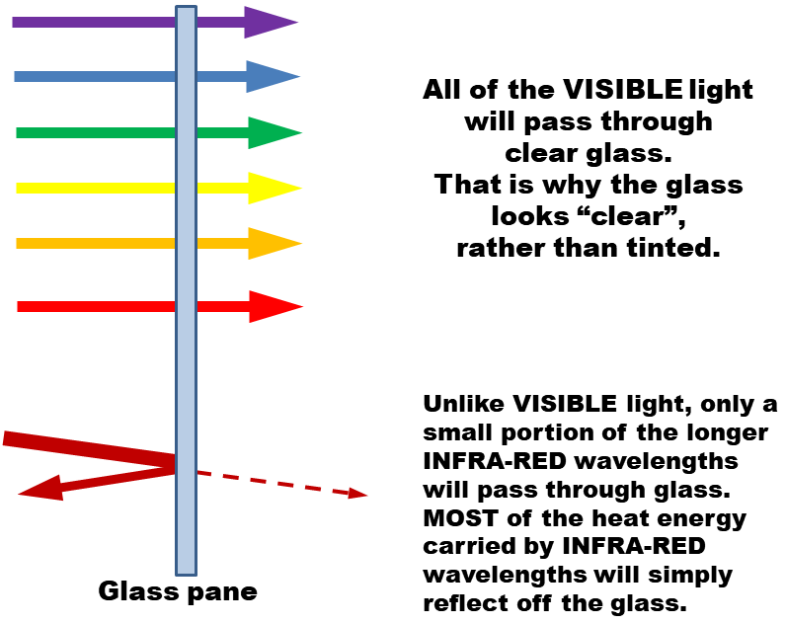
(2) The "visible light" energy which is carried by sunlight INTO A CAR, through the windshield and windows, will `hit’ the dashboard, seats, steering wheel, and anything else in the car which is NOT clear. And, when visible light `hits’ an opaque surface, some part of the energy in that visible light will be absorbed, in a way which turns that energy, into heat. For example, if the top surface of a dashboard, directly under the windshield in a car, is a dark blue color, that means that the plastic or polymer surface of that dashboard will be reflecting off some portion of the blue part of the spectrum, while absorbing the other colors (and, the energy being carried by those wavelengths) within the visible spectrum.
​ (3) When the plastic, polymer, or other material which covers the surface of a dashboard, car seat, steering wheel, or any other item inside a car, becomes hot, then this is what happens – and, this effect and result is central, critical, and absolutely crucial, to understand “the greenhouse effect”.
When things become hot, they begin trying to get rid of that heat (to stay in balance with their surroundings), by emitting (i.e., sending out) their own energy-carrying radiation. However, any heat-carrying radiation will be strongly shifted to the “heat-carrying” INFRA-RED portion (or range, segment, etc.) of the spectrum of wavelengths.
Why? Because, plain and simple, INFRA-RED wavelengths are the wavelengths that carry the most heat energy. As a simple example and illustration, here's a picture of a "HEAT LAMP" bulb, of the type that is used to warm food. These types of specialized light-bulbs can be found at any large hardware store, or online by searching on Amazon, Google, etc., for "heat lamp".
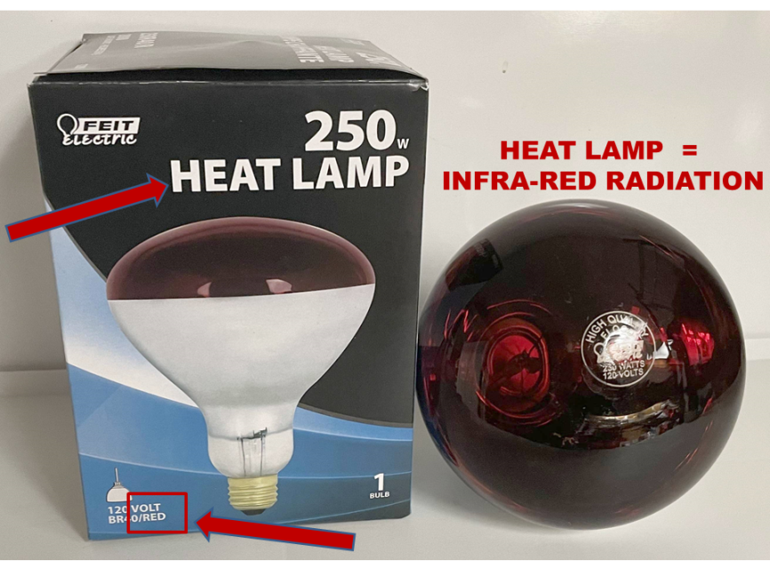
They are standard equipment, in nearly all restaurants and fast-food outlets, since they offer the best way to keep food hot, after the food has been cooked. At fast-food places, they usually are positioned over baskets that hold hot food. In sit-down restaurants, they usually are suspended (pointing downward) from the top of a wide horizontal window with no glass in it, which passes through in a wall between the kitchen and the main rooms. A cook -- in the kitchen -- can set a plate of hot food on a stainless-steel shelf which forms the bottom of that window, and the food sitting on that shelf will stay hot (because of the infra-red lamps, shining their heat-carrying IR radiation downward, onto the food), until a waiter or waitress picks up that plate with the food on it, and carries it to a customer.
​ (4) But now, here is where the problem arises, inside a car sitting in the sun with the windows rolled up. Infra-red light can NOT pass through the type of glass that is used to make car windshields, and windows. Instead of passing through that type of glass, infra-red wavelengths will be reflected by (i.e., they will bounce off of) the inside surface of a windshield, or window pane, in a car. And, when that happens, they are trapped, inside that car. They will bounce off of the inside surface of a car window or windshield, in some direction created by the angle of the glass at that location, and that will send the reflected infra-red rays directly back toward the interior of the car – where they will then transfer the heat they are carrying, to whatever surface they happen to hit (such as, the dashboard, or a seat, or the steering wheel). And, when those infra-red rays hit that surface, they will heat up that surface, even more. And, THAT – the fact that those heat-carrying infra-red rays are bouncing off the inside of the glass, and are being reflected directly back into the car interior, causing anything they hit to become EVEN HOTTER . . . is why the air, inside a car that is sitting in the sun with the windows rolled up, will become substantially hotter than the outside air.
Below is a picture which attempts to create a visual image, which attempts and hopes to illustrate, reinforce, and support (and drive home, and make memorable) this verbal description.
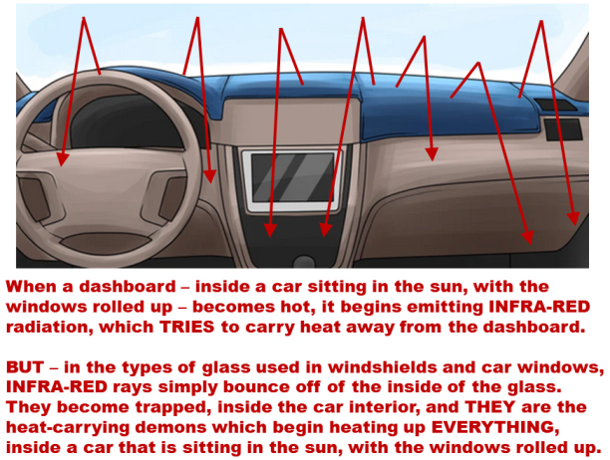
In the hope of helping more people understand what is happening, here is an analogy: to get a mental grasp of what "infra-red rays" can do, think of them as analogous to a swarm of angry and unpleasant little insects we'll call "heat bugs" -- worse than gnats, not as bad as hornets, somewhere on about the same level as a bunch of hungry mosquitos. When they feel threatened, disturbed, angry, etc., they will flap their wings, to try to get away from the problem. But, when they flap their wings, that ends up generating -- and releasing -- some level of heat. That is not some bizarre science-fiction fantasy; whenever energy is burned, to turn it into mechanical power, the process is never 100% efficient, and some that energy will be converted into unwanted heat. That happens whenever any kind of engine is run, such as a car engine, diesel engine, jet engine, steam engine, or any other kind of fuel-burning engine; and, even electric motors get warm, and sometimes hot, when they are run. So, assume, for the sake of the analogy, that when "heat bugs" flap their wings, some portion of the stored biochemical energy that is being converted into mechanical energy (i.e., the movement of their insect muscles) will be turned into heat.
So, if these "heat bugs" are trapped inside a car which is sitting in the sun, with all the windows rolled up, then they will feel threatened, and they will get upset and angry, when the inside of the car starts to get warm. So, following their insect-level instincts, they will begin flying around, inside the car, trying to get away from the heat. The problem is, when they start flying around, they begin generating, and releasing, even MORE heat . . . and, since they have become trapped, inside that car, because all of the windows are rolled up, THAT process makes the inside of the car even HOTTER. And, THAT makes the insects get EVEN ANGRIER -- which causes them to begin flapping their wings EVEN HARDER . . . which releases EVEN MORE HEAT, at an even faster rate . . . which makes the inside of the car EVEN HOTTER, STILL . . . which makes the bugs even angrier, still . . . which makes them . . .
Hopefully, anyone reading this will have realized, by now, that a "vicious circle" situation would be created, if "heat bugs" were real, and if swarms of them happened to get trapped inside of cars with all the windows rolled up, sitting in the sun. That type of "vicious circle" problem is described and illustrated, in these two slides:
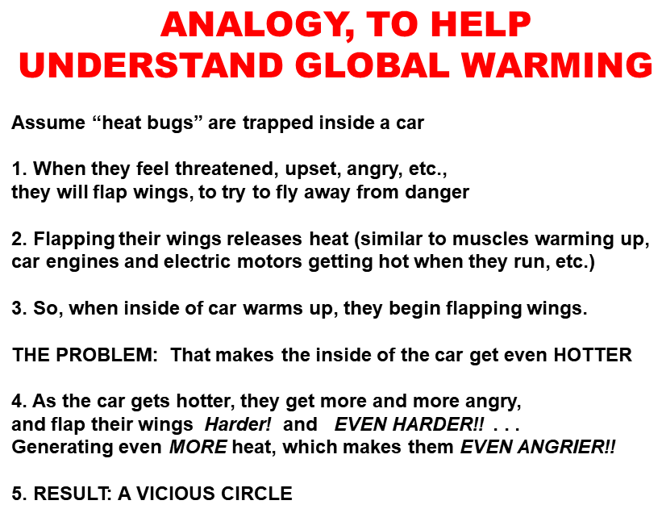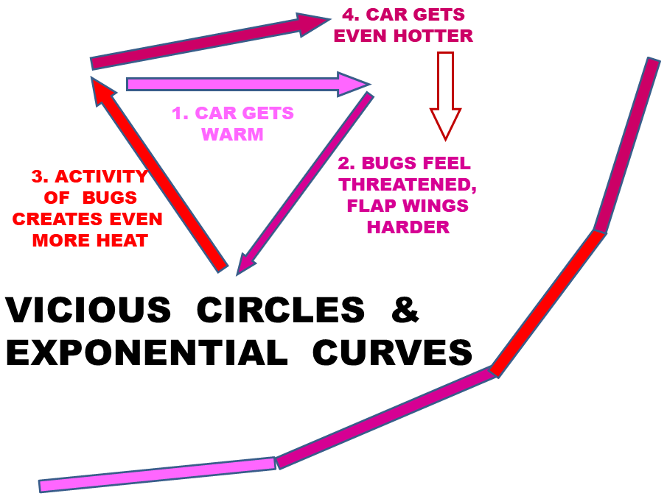

Shifting back out of that analogy, it is entirely serious and reasonable to refer to heat-laden infra-red rays as acting like "heat demons" when they are trapped inside a car, with all the windows rolled up. As the seat, dashboard, and other solid surfaces inside a car get hot, the infra-red rays become even more intense, and carry even more heat energy, and yet, they still remain trapped inside that car. So, they begin heating up the interior surfaces, inside the car, EVEN MORE! And, THAT causes the next round of infra-red radiation to carry EVEN MORE (!!) HEAT . . . and THAT causes . . . well, it creates exactly the type of "vicious circle" that is illustrated above, using hypothetical "heat bugs" instead of infra-red rays, to help people develop a stronger and more solid mental grasp and understanding of what actually happens, and why, inside a hot car on a summer day.
​ That EXACT SAME PROCESS, AND PRINCIPLE, explains how and why greenhouses – made of glass window panes mounted on a frame made of thin metallic supports – are widely used in the northern climates, to grow flowers and sometimes crops. Sunlight (with wavelengths that spread across the entire visible spectrum) enters a greenhouse (because the glass panes are clear, which means that the entire visible spectrum can pass through them). That sunlight warms up anything that the visible-spectrum radiation hits, which is not clear (such as the leaves of the plants inside the greenhouse, any wood or steel which was used to make any shelves which hold the plants, and the mulch, rubber mats, or whatever material covers the walking surfaces, inside that greenhouse). When those things warm up, they send out infra-red rays . . . and THAT is where the plot thickens, and things become both active, and interesting. THOSE rays – because they have a new, shifted, and different wavelength which can NOT travel back out of the greenhouse, through its glass windows – get trapped, inside the greenhouse. The infra-red rays reflect off the insides of the glass panes, and go back inside, in some inward direction, until they hit something else. That transfers their heat energy to whatever they happen to hit, inside the greenhouse. Plain and simple, that heat energy – which is being carried by infra-red radiation – is trapped inside the greenhouse, and cannot get out through the glass panes; and, so, that heat energy warms up whatever the infra-red rays hit, inside the greenhouse.
​ Now . . . why is any of that important, to understanding climate change, global warming, and "the greenhouse effect?”
​ Because EXACTLY that same process is occurring, in the earth’s atmosphere, where carbon dioxide, in the atmosphere performs EXACTLY the same role as a pane of glass, in a car windshield (or in a greenhouse).
​ Here are the facts, about how and why that happens: When sunlight passes through our atmosphere, and hits the surface of the earth, it will warm up whatever land, water, ice, or other surface it happens to hit, in exactly the same way that sunlight passing through a car windshield will heat up any dashboard, seat, or other surface it hits.
Then, when the surface of the earth (land, ocean, etc.) grows warmer, it tries to stay “in balance” by emitting some of that heat, BY MEANS OF RADIATION WHICH WILL BE IN THE (HEAT-CARRYING) INFRA-RED PART OF THE SPECTRUM.
BUT . . . those infra-red rays cannot travel back upward, through the atmosphere, and dissipate out into the vacuum of space, IF THE ATMOSPHERE CONTAINS TOO MUCH CO2 (or certain other gases, notably including methane). instead of being able to go back out into space, and dissipate into the black vacuum of deep space, a portion of those infrared rays will be bounce off of the CO2 and methane gases, in the atmosphere, and will be trapped inside our atmosphere, and will be reflected back downward, to the earth’s surface once again – where, those infra-red rays will transfer their heat energy to whatever they happen to hit, on that “second pass”.
In exactly the same way that a set of glass windows, enclosing the air inside a car, will cause the air inside that car (as well as any solid surfaces, inside that car) to get hotter . . . in exactly that same way, a layer of gas having too much CO2 and methane, which completely encircles this planet, will create what becomes, effectively, an “enclosed system” that can no longer get rid of heat in the same way (and to the same extent) it previously did (i.e., by sending infra-red radiation out into deep space).
​ So . . . THAT is the FIRST essential fact I would like to put on the table, for discussion by any and all candidates for Congress, and for questions by any and all voters who must choose between candidates.
If anyone believes they can describe and explain that fundamental fact, in a better, more clear, more understandable way, to non-science audiences, then, please -- post a video, of you explaining whatever you are trying to explain, on YouTube, Instagram, Facebook, or TikTok.
Or, regardless of whether you think you can do BETTER, if you would like to add YOUR voice, and YOUR face, and YOUR efforts, to the chorus, in the hope of making it a bigger and better chorus . . .
​ Either way, the challenge is this: "Give it YOUR best shot." My goal is plain and direct: I'm trying to start a process that will require political candidates to either learn about, recognize, and acknowledge a specific set of facts, or to openly try to deny or sidestep those facts. My goal is to enable voters to see and hear what the candidates actually do, and say, when confronted with the assertions of fact set forth herein, so that either way, voters will know what that candidate did, how much that candidate actually knows about the biggest problems he or she will ever have to face, and whether that candidate has enough courage and integrity to actually face up -- squarely, honestly, and as a true `public servant' -- to those facts. I am NOT advocating massive programs, massive spending, or massive anything else. Instead, I am simply trying my best to put forth and explain a set of facts, in ways people that people can either acknowledge, or try to reject. That is my only -- my true, and sincere -- goal, for the 2022 election cycle.
Why?
Because I have become convinced that the severe failures of scientists and environmental advocates, over the past 30 years, to be able to create and drive any actual and genuine progress, within Congress, to even recognize and understand the problem (let alone, trying to actually solve it), has been largely due to the failure of scientists and others to set forth a carefully-selected and carefully-explained set of actual, demonstrable facts, in convincing and hopefully even compelling ways that politicians would have to face up to, and either accept, or try to evade, in ways they can be held accountable for.
​ If you think you even MIGHT be able to help, then, please, at least try.

CRUCIAL GLOBAL WARMING FACT #2:

THE BRIGHT & REFLECTIVE SNOW COVER THAT USED TO PROTECT THE (NORTHERN) ARCTIC IS BEING TOTALLY DESTROYED

The SECOND absolutely crucial, critical, earth-changing fact about global warming and climate change, which every voter (and, even more, every candidate for Congress) should know about, is this:
In the arctic north, the amount of “snow and ice cover” – which formerly provided a bright white (sunlight-reflecting) layer, on top of much darker ocean and land surfaces – have decreased to a huge and deeply frightening extent. The reason why that loss is so dangerous and disturbing, is described in Crucial Fact #3, below; by contrast, this Crucial Fact #2 merely discusses the size of the arctic area which has lost that protective cover.
The decreases in arctic snow and ice cover are the single best, most powerful, and most undeniable indicators of how serious (and even dire) the situation has become. Why? Largely because the facts are what they are, and those facts cannot be denied, or pretended away, either by climate change deniers, or by politicians in Congress. By 1979, satellites – which do not have political agendas, and which do not need to seek campaign contributions, or run for re-election – began taking sufficiently detailed and accurate pictures, of the northern arctic, to enable impartial, objective, non-biased comparisons of today’s arctic conditions, against the 1979 conditions. When the satellite pictures of today are compared against the pictures from 43 years ago, they just plain show what they show, and no one can claim or pretend otherwise. Therefore, most climate change deniers (especially those in Congress) try to find ways and excuses to ignore them, and pretend that either: (i) it's not their job, or responsibility, to understand what those particular pictures show; or, (ii) surely, there must be some kind of explanation, or evasion, which can explain away those pictures.
But, there isn't a better explanation than the one summarized below. So, anyone who wants to engage in any serious and informed political debate over global warming – and any voter, interviewer, or debate moderator who wants to ask questions of candidates for Congress – should know what is undeniably happening in the northern arctic region.
The pictures that are used to compare year-to-year changes are taken in September, when the arctic ice and snow cover is at its lowest point. That does not indicate bias; instead, it is a straight-forward and logical way to gather, and provide to decision-makers, the best and most useful comparative information, to show what is actually happening, year after year.
And, in addition to using cameras that take pictures in the visible spectrum, some satellites also use X-rays or other parts of the non-visible spectrum, to detect, not just the areas covered by snow or ice, but also, the thickness and depth of that snow and ice cover, on top of the surfaces (land, or water) that the snow and ice rest upon, at any location.
There also is an impartial scientific agency called the National Snow and Ice Data Center (NSIDC), which brings together experts from several federal agencies. It is tasked with evaluating ice and snow measurements and data from around the world, especially in the artic, Antarctic, and Greenland. Its website is at http.nsidc.org.
Because most people cannot convert huge numbers (such as hundreds of thousands of square miles, or kilometers) into a quick and practical grasp of what is being said, the NSIDC has chosen to express the most important numbers – describing the size of the area which has flat-out LOST (i.e., entirely, so that dark water or land surfaces have become visible) its snow and ice cover – as multiples of the size of the state of New Jersey. Most people can at least begin to grasp and understand how large the entire state of New Jersey is, at a level which is at least somewhat meaningful; so, using a multiple of THAT much area, makes more sense than some huge number of square miles or kilometers.
The official numbers (and photographs), from the September month of each successive year since 1979 (when sufficiently detailed satellite images became available to enable these kinds of analyses), show that the amount of snow and ice cover, in the arctic – which formerly helped protect and stabilize the arctic region – which has totally disappeared, since 1979, by about ONE HUNDRED AND TWENTY FIVE times as much area, as is covered by the entire state of New Jersey.
And, to make matters even worse, the thickness of the remaining snow and ice cover also has dropped – severely, dramatically, and dangerously. During that same time span (since 1979), it has decreased by more than half – from an average of 2 meters (which is about 6 feet, 7 inches) in 1979, to less than 1 meter (about 39 inches), today.
In complete seriousness, to get a mental handle on what that means, close your eyes, and pretend you are looking at a dwarf, only 3 feet tall, standing next to a professional basketball player who is 6’7”. That is the true and practical difference, between those two heights. They are NOT the same TYPES of people, and they do NOT have the same physical strength or capabilities.
​ Without trying to be cute, or flippant, it is reasonable to point out that most people – if obliged by circumstances to choose a bodyguard to help protect them, in a place that is known to be hostile, dangerous, swarming with thieves and desperately hungry poor people, where “kidnaping for profit” is one of the few profitable industries – most likely would choose an extra-tall, extra strong, ex-professional basketball player, rather than a dwarf, to protect him, his wife, and his children. What we have done, to the arctic, is comparable to telling it, “Sorry, but we killed off all the basketball players who used to live up here. All we have left, now, is some dwarves."
And, as the final crucial point, the snow and ice cover that remains, has become substantially – even severely – more porous, more hollow, less dense, and less strong, than it was, back in the 1980’s.
So, the person who is telling you, "All we have left, now, is some dwarves," would also have to add, in order to be honest and candid, "And we also need to warn you that these dwarves also suffer from severe osteo-porosis, which means that their bones have become fragile, and can be easily broken. And, they’re also getting pretty old, themselves, and they keep dying off, in pretty large numbers, each year. So, all we can do, now, is tell you the facts, and wish you luck.”
Those numbers – the HUGE area where snow cover has been totally lost, as well as the reduced, hollowed-out, porous and weak thicknesses, in areas where any snow cover remains – are not frightening, merely because they are large. They become doubly (or triply) frightening, to anyone who also understands the NEXT crucial fact . . .
CRUCIAL GLOBAL WARMING FACT #3:
​WHEN THE SNOW COVER DISAPPEARS, THE MUCH DARKER LAND OR OCEAN SURFACE WILL BEGIN ABSORBING EVEN MORE HEAT ENERGY, MUCH FASTER THAN WHEN PROTECTED BY SNOW
The THIRD crucial, critical, earth-changing fact about global warming and climate change – which any voter, and any candidate for Congress, should know about – is this:
As has been known for thousands of years, when different things having different colors are left outside, sitting in direct sunlight, nearly anything (including plain old rocks) that are white colored (or even just light colored) do not heat up, as much as things which are black (or even just somewhat dark).
When scientists began creating ways to measure the differences in energy absorption by different-colored things, they chose the word "albedo" (which, like "albino", derives from the Latin word for "white"), to refer to how much of any incoming light energy is reflected off of an object, and how much is absorbed by that object.
The albedo scale stretches only from zero, to one. A perfect mirror – which reflects back absolutely all of the light which hits it – is at the very top end of the scale, with an albedo value of 1 (or, very close to 1).
At the opposite (zero) end of that scale, a lump of charcoal (i.e., partially burned wood which is totally black, and which has a pitted and irregular surface, rather than a shiny or glossy surface that might reflect light) is close to zero, and has an albedo value of about 0.04. The fact that charcoal is not a perfect zero, is what allows one to see and study the pitted and irregular surface of a charcoal briquette. If charcoal had an albedo of absolute 0.0, it would simply look like a perfectly and totally black object, with no distinguishing features at all.
The "albedo" level of freshly fallen snow usually is in the range of about 0.8 to 0.9 (the exact number will depend on various factors, including packing and density, water content, etc.). Those are among the highest numbers that exist for anything that occurs naturally (since polished mirrors, which can have even higher numbers, do not occur in nature). As snow grows old, and becomes covered with dust, and pitted in irregular ways, it can drop to levels of about 0.5.
And now, here comes a very, very different albedo number, which is deeply frightening, to anyone who knows about it, and understands what it means to global warming.
Anyone who has ridden in a boat, on a hot sunny day, and who has been nearly blinded by the glare of sunlight reflecting off the water, might assume that a water surface, in an ocean, sea, or lake, must have a fairly high albedo number. However, the exact opposite is true; and, anyone who has been nearly blinded, by the glare of sunlight reflecting off the surface of a body of water, should regard that fact as, actually, more of a display of (and a warning about) the remarkably high levels of energy carried by sunlight.
Instead of reflecting some significant portion of the energy carried by sunlight, any large body of water (an ocean, sea, bay, gulf, lake, etc.) will instead absorb very nearly all of that energy. In the past, that fact was a wonderful thing, for this planet, and for all life on earth, since sunlight energy which penetrates a water surface, and then travels up to several hundred feet below that water surface, is the energy that plankton, diatoms, algae and other microbes, corals, kelp and other types of seaweed, and other forms of marine life, use, and need, to grow; and, those types of marine life (i.e., the producers, rather than the predators) provide pretty much the entire foundation, basis, and support for all the other forms of marine life (including fish, crustaceans, and any other organisms that do not use sunlight and photosynthesis as their energy supply). If most of the energy in sunlight reflected off the surfaces of water, there would be very, very little marine life of any sort (and almost none, with any real variety), on this planet.
Accordingly, the albedo numbers of ocean surfaces can be seriously compared only to the albedo numbers of lumps of charcoal, which is "dark black". As mentioned above, the albedo level of charcoal is about 0.04, which is pretty darn low. Because any body of water absorbs (rather than reflects) nearly all of the energy offered and delivered to it by sunlight, the albedo level of the surface of an ocean, or sea, or gulf, or bay, or lake, is only about 0.06 (i.e., only slightly higher than charcoal).
The almost-perfect, almost-complete absorption of sunlight energy, by water, truly has been a wonderful and magnificent gift of nature (or of God, for those who think in such terms), when it comes to creating and supporting marine life. But, in modern times, and in the arctic ocean in particular, we need to think about global warming, instead.
For the last 10,000 years or so (since the end of the last major Ice Age), since most droughts and floods have been localized (rather than global in scale), the planet that is our home has been settled into a wonderfully nice, comfortable, and stable balance, for the needs, comforts, happiness, and growth of humanity. But . . . all that is about to change. The blanket of snow and ice which pretty much covered the entire arctic region, even during the summer months, and which helped sustain the marvelous and mostly comfortable climate on this planet for the past 10,000 years, has been suddenly and severely shifted – some would say disrupted, or even destroyed – irreversibly. The nice bright snow and ice covering which, until recent years, was able to reflect off (i.e., able to send back out, into deep space) 80 to 90 percent of all the heat energy that was shining on that bright white snow and ice, has now been pretty much destroyed, and dismantled – especially during the summer months, which is exactly when the sun is actually shining, on that part of the globe. Now, huge and unprotected arctic ocean surface areas (which begin growing larger when spring begins, and which keep growing larger until they are more than 125 times the size of the entire state of New Jersey, by the time September arrives), have already started to absorb almost 95% of the energy that is carried by sunlight, which is now directly hitting, and penetrating into, those dark blue ocean surfaces, rather than reflecting off a bright white snow and ice cover.
For reasons that should be obvious to nearly anyone who can actually think, the shift from a stable first condition (where more than 85% of the energy was being reflected out into space, by a bright white covering layer), to a totally different second condition (where nearly 95% of that energy is now being absorbed, by now-naked dark blue surfaces) has already reached, and passed, a point where it has become (and will continue to become, even more) something that can be called a "self-reinforcing" condition (or, a "self-accelerating" condition, or a "runaway" problem). All three of those phrases mean, in effect, "The worse things become, the more they will become even worse, even faster; and then, they will become even WORSE than THAT, even FASTER than that! And we cannot see any end, whatever, to that problem. We simply do not know, and cannot guess or predict, just how bad it will become, before it finally levels off, somehow."
That type of effect is sometimes called "a vicious circle", and, that phrase can be useful. However, it runs the risk of trivializing, in the minds of many voters, how urgent and potentially catastrophic the situation is, which the arctic ocean is now facing. Almost everyone has experienced, at one time or another, some sort of "vicious circle" argument, or feud, or other problem; and, in almost every case, that argument, feud, or other problem got solved, with the help of some sort of intervention, by someone who figured out how to put a stop to it. So, the natural (and appealing) response is to hope (and try to persuade oneself) that, somehow or another, someone will show up who will be smart enough, wise enough, mature enough, and strong enough to intervene, somehow, and disrupt that "vicious circle", in some way that can put a stop to it.
But this time – since the self-accelerating, self-reinforcing, runaway problem already has become 125 times the size of the entire state of New Jersey – there isn't anyone who will be able to do anything which is even remotely comparable to "intervening" in a helpful way, in some limited and small "vicious circle" argument between two people, or two families. Because now, the entire planet is in deep, serious, "self-accelerating" trouble. The disappearance of the bright white and highly reflective snow and ice cover, from the arctic north, has already passed a critical threshold, and that loss has already begun to accelerate the melting, destruction, and loss of even more of whatever is left of that protective white cover, at even faster rates. We have reached, and passed, a point where the new losses that will occur, pretty much every year, from now on, will become even larger, and faster, than the losses that occurred just one year earlier.
The experts can tell you how fast the snow and ice cover has already been disappearing, in the arctic north. However, even their best and most current and sophisticated computer models can only guess at how much faster the remaining snow and ice cover areas will melt and disappear, in the future. The only thing we can guess and predict, with a reasonable level of confidence and reliability, is this: "It is going to continue melting and disappearing, and it almost certainly will begin melting and disappearing even faster, at ever-increasing rates, until the entire white and protective cover of snow and ice, over the entire arctic ocean and the far north regions, is gone."
​ As a brief aside, it might be a good and useful idea, for climate scientists to switch out of the “albedo” scale, which effectively measures whiteness, and change to an “energy absorbing” scale. It would be a simple matter, merely involving the step of subtracting an albedo number, from 1.0 (and, if desired, the resulting number could be multiplied by 100, to convert it into a percentage number). Since snow and ice are bright white and highly reflective, their albedo numbers, of about 0.85 on average, reflect “energy absorbing” levels of only about 0.15 (which can also be written as 15%). By contrast, since charcoal has an albedo number of 0.04, it would have an “energy absorbing” index of 0.96 (or, 96%). Ocean water, with an albedo number of 0.06, would have an “energy absorbing” index of 0.94 (or, 94%).
That is suggested, party to reduce confusion, and partly as a statement that we now must become deeply, deeply concerned, with just how much energy (mainly from sunlight) is, indeed, being absorbed, in the arctic, by surfaces that are much darker, and much more energy absorbing, than the protective layers of bright white snow and ice which used to cover the arctic.

CRUCIAL GLOBAL WARMING FACT #4:

THAWING OF TUNDRA AND PERMAFROST IS RELEASING GIGA-TONS OF METHANE, WHICH IS 25-28 TIMES WORSE THAN CO2, AT TRAPPING HEAT
The FOURTH absolutely crucial, critical, earth-changing fact about global warming and climate change, which any voter (and any candidate for Congress) should know about, is this:
As the arctic regions get warmer, the land regions that commonly are called "tundra" and/or "permafrost", have already begun melting, at huge scales, and will continue melting at even faster rates, in the future. This is already being seen in very large areas in Siberia, the northern Scandinavian countries, and the northern parts of Canada.
And, here is the critical problem which is being made even worse (and potentially catastrophic), by the melting of large areas of tundra and permafrost: those melting areas are beginning to release, into the atmosphere, HUGE quantities (usually expressed in GIGA-tons) of methane.
For those who might need a brief refresher, methane is a gas, under normal unfrozen conditions. It is the absolute lightest `organic’ molecule (defined as, having at least 1 carbon atom), as well as the absolute lightest `hydrocarbon’ (defined as, having no atoms other than carbon and hydrogen). It has only 1 carbon atom, surrounded by four hydrogen atoms, so its formula is CH4. It is (by far) the largest and most important gas in `natural gas’ (which also contains much lower quantities of ethane and a few other small organic molecules), which is one of the main fuels used for heating buildings, and for generating electricity.
Why does the unfreezing – and release into the atmosphere – of multi-GIGA-ton quantities (the prefix `giga-’ refers to a billion units, so a `giga-ton’ is a billion tons) of methane gas – which, for millions of years, has been "locked" into the dead grasses, hard-frozen mud and ice, and other materials that make up tundra and permafrost – create even more serious problems, for global warming?
The answer is because of each and both of two factors:
(i) when measured on any equal weight basis (e.g., pound-for-pound, ton-for-ton, etc.), methane gas is much-much-much "more potent" (also known as, more powerful, more effective, more dangerous, more destructive, or any similar terms) than carbon dioxide (i.e., CO2, the "classic" greenhouse gas), when it comes to trapping and holding in "infra-red" radiation (which is exactly the same type of heat-carrying radiation described in the "Crucial Fact #1" section).
(ii) Each molecule of CO2 in the atmosphere is likely to last thousands of years (it is a VERY stable, low-energy molecule, and therefore, about the only thing that can change it into something else, is when a plant, algae cell, or other organism grabs it, and uses photosynthesis (as an energy source) to break the carbon out of the CO2, and place that carbon in a larger organic molecule. By contrast, CH4 (methane) is a relatively unstable, high-energy molecule, so it can be converted into other things, in a much wider variety of chemical reactions, without needing plants or photosynthesis. As a result, each molecule of CH4 typically will last only about 10 years, in the atmosphere, compared to a thousand or more years, for a molecule of CO2.
To deal with that complicating factor, scientists have adopted comparison numbers, called "Global Warming Potential" (GWP) ratios, to help them factor in all of the variables that will affect how much "damage" (in terms of, `contributing to unwanted global warming') a ton of CH4 (or any other `greenhouse gas') will ultimately inflict on the environment, compared to a ton of CO2 which reaches the atmosphere. The estimates that have emerged, from those studies, is that each ton of CH4 which is released into the atmosphere will cause about 25 to 28 times as much "global warming damage", as each ton of CO2 which is released into the atmosphere. More information is provided by sources such as the U.S. EPA (www.epa.gov/ghgemissions/overview-greenhouse-gases) and the "Global Carbon Project" (www.globalcarbonproject.org/methanebudget/20/files/GCP_MethaneBudget_2020_v2020-07-15.pdf).
When a heated planetary surface (either land, or water) tries to send infra-red radiation (which, again, carries heat energy) out into deep space, as a way of maintaining a normal, healthy, and stable temperature and climate, methane gas is like an extra-super-hyper version of CO2, on steroids and amphetamines. Methane is bad, bad stuff, once it reaches the atmosphere. Melting permafrost and tundra regions have already released multiple giga-tons, of that really bad stuff. And, as things grow worse, the quantities and weights of the "even more" methane gas that will be released into the atmosphere, every year, will grow even larger, and will threaten (quite seriously, and realistically) to create yet another "runaway" (or `self-reinforcing’, `self-accelerating’, etc.) crisis, of the same type described above.
In other words, as the far-northern arctic regions get warmer, they will begin releasing even more methane gas, at even faster rates than are occurring now.
And, as even MORE of that methane gas is release, causing it to trap even MORE heat, the rates of additional warming, in those northern regions, will become even faster.
And, as those rates of additional warming grow even faster, they will accelerate and drive the release of even still more methane gas – which will then cause even still more faster global warming. Each part of that "runaway" cycle will make the other part even worse, with no end in sight, until pretty much ALL of that methane has been unfrozen, and unlocked, and then released as free gas, into the atmosphere.
About all one can say, realistically, is, “Ummm . . . that does NOT look good, for us.”

CRUCIAL GLOBAL WARMING FACT #5:

GREENLAND ALREADY HAS LOST 5.5 TRILLION TONS OF ICE SINCE 1970
The FIFTH crucial, critical, earth-changing fact about global warming, which any voter, and any candidate for Congress, should know about – even if they do not memorize or remember any of the numbers below – is this:
The Greenland ice sheet is being destroyed. It is being dismantled. It is being wrecked. The water that it once held, is now running off of the surface of Greenland, and into the oceans, in the form of "ice-melt" rivers which simply did not exist, twenty years ago.
A first number might help people understand just how incredibly fast this is happening: on a single day, in August 2021, a complex and coordinated set of measurements were taken, by multiple teams, at multiple locations (including unmanned locations, with various sensors coupled to data transmitters), all around Greenland, to get the best actual measurements the researchers could get, to see just how fast the Greenland ice sheet is being destroyed.
Their measurements indicated that on just that one, single, specific day, nearly 20 billion tons of water, which had melted, ran off of the Greenland ice sheet, and entered the ocean.
As a brief aside, the actual number set forth in the websites and reports, was 18 billion tons of water lost, from Greenland, on that one day in August 2021. However, researchers in Greenland use metric weights, rather than the “English” system. Since a kilogram is equal to about 2.204 pounds (i.e., English pounds), a metric ton is only 1000 kilograms; but, that number translates into about 2204 pounds. So, any measurement which is reported in metric tons, must have another 10% added to it, to convert it onto the “English” tons that American voters know about, and understand. Therefore, 18 metric tons is equal to 19.8 English tons; and, all tonnages referred to herein have been converted into English (American) tons (i.e., 2000 pounds).
Another number describes the total amount of ice that has been lost, and dumped into the ocean, from the Greenland ice sheet, over the past few decades. There are several ways to write this number; and, several of those ways are listed below, in the hope that at least ONE of those numbers will somehow land, and stick, in the minds of at least some voters, and some candidates for Congress:
Version 1: FIVE AND A HALF (5.5) TRILLION TONS of water have already melted from the Greenland ice sheet, and have been added to the oceans on this planet, since about 1970;
Version 2: FIVE AND A HALF . . . THOUSAND . . . GIGA-TONS (i.e., five and a half THOUSAND units, with A BILLION TONS, IN EACH AND EVERY UNIT) have already melted from the Greenland ice sheet, and have been added to the oceans on this planet;
Version 3: FIVE AND A HALF . . . MILLION . . . MEGA-TONS (i.e., five and a half MILLION units, with a MILLION TONS in each and every unit) have already melted from the Greenland ice sheet, and have been added to the oceans on this planet.
And now, here is another fact: if anyone does a Google IMAGE search which combines "Greenland" with "rocks", most of the pictures that will appear, will shows rocks and mountains that are unusually dark shades of gray; many of them can fairly be described as "almost black." There are some pictures of lighter-gray rocks, mostly with unusual swirls and other patterns showing on their surfaces, but almost none of those also show a segment of sky, to help a viewer "calibrate" what that photographer did, when taking that picture; so, it is likely that some photographers who took those pictures had adjusted their camera settings, to make those rocks appear lighter-colored, to emphasize the swirls or other patterns on their surfaces.
The fact is, Greenland contains the most ancient rocks that have ever been discovered, on this planet. Almost all of its surface layer is classic "igneous" rock, in the granite and basalt categories, created directly by the cooling of lava (or "magma"), as the surface of the planet cooled down and solidified, very early during the formation of the planet. As a result, the rocks which are being exposed, as the Greenland ice sheet melts, are darker than most of the land areas in most other parts of the world. Therefore, as soon as the unusually dark rocks in Greenland are exposed to sunlight, by the loss of snow and ice cover, they begin grabbing and absorbing heat energy carried by sunlight, at exceptionally high rates.
And, so, the rates at which the Greenland ice sheet will melt, and run off the rocks, and into the ocean, will continue to grow faster, and faster, and even faster than that, as more and more of its snow and ice cover is lost. In other words, the melting of the Greenland ice sheet poses yet another "runaway" (or self-reinforcing, self-accelerating, or similar terms) condition, which will speed itself up, and occur at even faster rates, the more it continues to happen.
Okay, then . . . this is where the discussion of snow and ice cover, and albedo, will stop, even though it hasn't yet even touched on Antarctica.
Why not get into Antarctica, as well, here and now?
Because, to most voters in the United States, Antarctica seems VERY remote, and VERY far away (and, VERY cold, as well). So, any warnings or dire predictions about things like the Thwaites glacier (also called "the doomsday glacier", for a good reason that most politicians do NOT want to know about, or have to discuss in public) have not yet really begun happening – or, at least, not to the same levels as in the northern arctic, where total and undeniable losses of ice and snow cover over huge areas have already happened, and can be described, factually and accurately, without having to wait for anything else to happen. By contrast, the gradual melting and dismantling of Antarctica must be described, mainly in terms of what MIGHT happen, someday, if the world continues to grow warmer; and, those types of warnings have not yet become facts, the way that each and every one of the facts listed above is already – and undeniably – happening.
And, as another brief aside, from a long way away . . . the Great Barrier Reef, off the Pacific coast of Australia . . . surely you’ve heard of it? Well, in case you have NOT heard, it is dying. Rapidly. VERY rapidly. Over just the past 10 years, it has become about 70% dead, because the water surrounding it has become too hot for the types of coral that used to thrive there. It took hundreds of millions of years for corals to build it, and until recently, it was called the largest living thing that has ever existed on the face of this planet, and the only living thing that can be seen readily from space. But, gosh . . . global warming has managed to pretty much kill it, in only about 10 years. If anyone would like to watch it happen, there are videos showing it, at places like youtube.com/watch?v=gW789yyt7q0, and youtube.com/watch?v=i8CnA2fKpvI.
And, oh yes, the Amazon forest, too. It has been called `the lungs of the earth', and with good reason. Well, it is being actively destroyed, usually by clear-cutting and fires (mainly by people who want to grow cattle on that land, even though that type of soil will not support cattle for more than just a year or two). In addition to that outright and direct destruction, scientists also have begun to realize that its `resiliency' (i.e., its ability to repair damage that it has suffered) also is being severely damaged, and impaired, to a point where scientists have begun to suggest, in complete seriousness, that within a few centuries, or possibly only within a few decades, huge portions of it may turn into the type of dry and even semi-arid grassland which, in Africa, is called `savannah'. And, if THAT happens, it likely would become a catastrophe for pretty much every type of vertebrate animal that is alive today. This planet has already firmly and irreversibly entered `The Sixth Great Extinction Event' in its history, which humans know about. If humans destroy the Amazon rainforest, and turn it into semi-arid grassland (instead of a rainforest which, today, holds on to unimaginably huge quantities of carbon), that might actually and seriously lead to insects, jellyfish, and other `non-vertebrate' animals becoming some of the most advanced and important forms of life that would remain alive, on this planet.
And, some people might feel short-changed because this account doesn't get into the droughts and wildfires that are wreaking so much havoc in the American West. Since droughts and wildfires have always been part of nature (at least, since the end of the last Ice Age, about 10,000 years ago), it's very, VERY hard to somehow convince Republicans -- especially Republican members of Congress -- that THESE fires, and THESE droughts, are somehow "different" from all the ones that have happened before. So, all I can do, on that front, is offer up a couple of pictures, in the hope that they might create some sort of visual impression which will create a memory that might linger for more than two minutes.
I've chosen these, because they are NOT located in the already-generally-dry Southwest, in a state like Arizona or Utah. Instead, these pictures are of Lake Oroville, which is more than 100 miles NORTH of San Francisco, which is already considered part of NORTHERN California. That lake is about halfway between San Francisco, and Oregon. Here is what Lake Oroville looked like, in happier, healthier days:
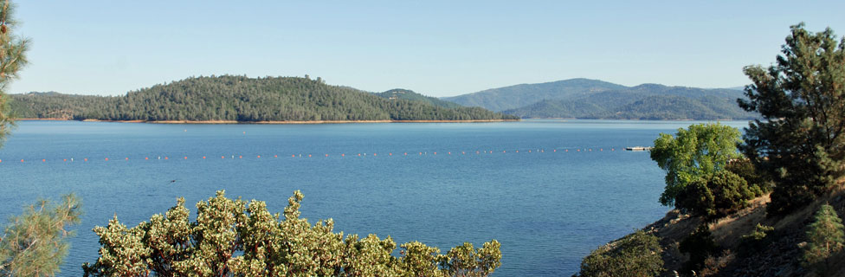
But, here is what it looks like, today:
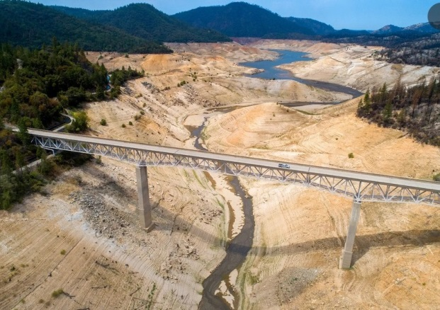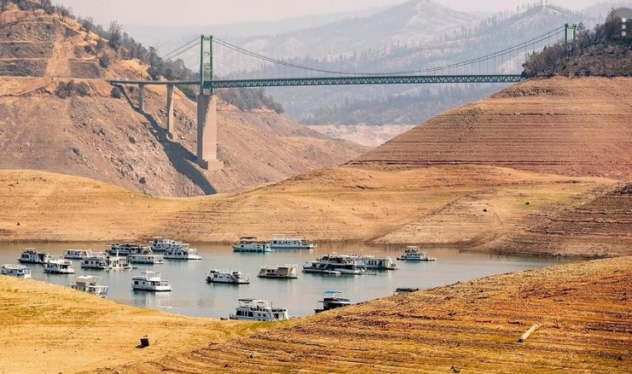
How can ANYONE look at these kinds of pictures, and NOT realize that something is very, VERY seriously wrong? I certainly can't; so, all I can suggest is, go ask some Republicans. Especially some Republican members of Congress. Or, Republican candidates for Congress. THEY are the ones who are refusing to face up to the reality of what is actually happening, these days, because of global warming. If some debate moderators would show an audience some pictures like these, and then ask any Republican candidates for Congress, "Do you see any problems, here?", perhaps they might get at least some vague deflections about promises to maybe do something, some day . . . maybe. Or, they might get to see and hear some really useful -- and really helpful -- sidesteps and dance moves, about how it should be private enterprise, rather than any sort of government programs, that should be used to solve these kinds of problems.
Anyway . . . the NEXT page will move on, to a different set of facts, mainly about the threats that global warming poses to nice, warm, comfortable coastlines . . . coastlines where lots and lots of people (about THREE BILLION people, for anyone who wants an advance peek at THAT number) live . . . and prefer to live . . . at least for now.

CRUCIAL GLOBAL WARMING FACT #6:

WORLDWIDE SEA LEVELS ROSE ABOUT 8 INCHES OVER THE LAST 100 YEARS. BUT NOW, THEY’RE RISING MUCH FASTER. THE BEST PREDICTIVE MODELS SAY THEY “MOST LIKELY” WILL RISE MORE THAN 14 INCHES, IN THE NEXT 40 YEARS
When people ask, `Have we been able to measure, and prove, that sea-levels are actually rising?', one of the standard evasions, used by climate change deniers (I prefer to call them `paid disrupters') is to begin spewing out numbers, with the deliberate intent of making the numbers (and the issue itself) complicated, hard to follow, hard to understand, impossible to remember, and impossible to explain to anyone else. We need to simplify things, and the subheading above is an effort to do exactly that. Plus, if two straightforward facts are placed directly next to each other and compared, they should be enough to help at least some voters understand, a bit better, the dangers that are coming at us like a runaway train, with us trapped on the tracks.
Fact 6.1: Over the past 100 years, sea levels rose, at least 8 inches. Sources, for that? Well, the U.S. Navy, for starters. As patriots, and as people who have dedicated their lives to helping keep America strong, Republicans and conservatives can and should trust the Navy, more than they trust Democrats. Plus, the Navy is in a line of work where they NEED to know the actual hard facts, about sea level rise.
However, I must also add that the Navy does NOT like to issue clear, direct, uncluttered numbers -- presumably, because they do NOT want to confront and antagonize the members of Congress who control their budgets, and who do not want to be confronted by facts set forth so clearly and directly that they would seem to be deliberately provoking, taunting, and needling those who do not want to know those facts. I have seen dozens of reports that dance all around the actual numbers, and only a very few which actually say them, and explain them -- and those few were in almost all cases written by reporters, consultants, and others, to help the Navy avoid having to actually sign and release such statistics. As just one example, in which the 8" number must be derived from other numbers that were provided, See www.physicstoday.scitation.org/doi/10.1063/PT.3.3163
As a second brief note about PAST sea level rises, our coastlines are already suffering from major, MAJOR problems, because of that 8 inch rise, in the last 100 years. Think of what Hurricane Katrina did to New Orleans, and what Hurricane Sandy did to New Jersey and New York. Those are hard, undeniable facts. If sea levels continued to rise at just that OLD rate (8 inches/century), those problems would keep getting even WORSE. But, that’s not happening.
​ Fact 6.2: The SECOND part of the REAL problem is, things are going to start getting a whole lot WORSE, a whole lot FASTER. The current best prediction, based on extensive and careful computer modeling – improved by continuous updating, to reflect new data that are being gathered all the time – is this: the known rates of sea-level rise are on pace to exceed A WORLDWIDE AVERAGE OF 14 INCHES, over JUST THE NEXT 40 YEARS.
People need visual images, to help them get a better sense of what is really happening, so here is a single, straight-forward graph (with more explanation, below), comparing:
(1) sea level rise over the PAST 40 years (from 1980, to 2020), as a 40% fraction (i.e., 3.2 inches) of the 8-inch rate of rise during the past 100 years; and,
(2) the projected sea level rise over the NEXT 40 years (i.e., 14 inches, 2020-2060).
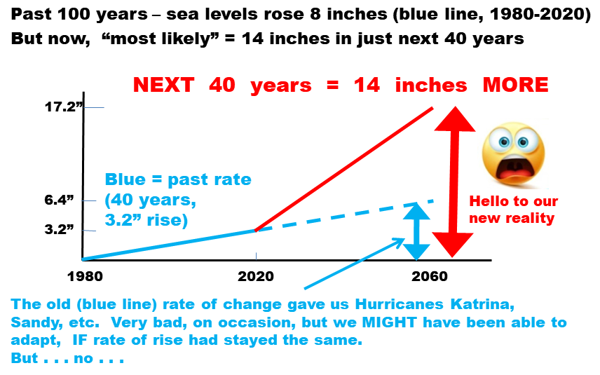
The “14 inches in the next 40 years” number also is consistent with the updated analyses issued in February 2022, by the National Oceanic and Atmospheric Administration (NOAA). That analysis also predicts sea level rises of more than a foot, just within the next THIRTY YEARS, starting NOW. Over just the next 30 years, predicted sea level rises along the Atlantic are predicted to be 10 to 14 inches for the Atlantic coast, and 14 to 18 inches for the Gulf coast. Even though they don’t cover the exact same span of decades, the NOAA forecasts align so well with the Navy forecasts, that anyone and everyone should take the warnings, in both sets of projections and predictions, very, VERY seriously, rather than trying to create quibbles, clutter, confusion, and evasions over the minor differences between them.
And, if THAT still isn’t enough, the so-called “Intergovernmental Panel on Climate Change” (IPCC), a scientific group put together by the United Nations, also came out with its most recent update, in February 2022, on just how dire the situation is becoming, and how rapidly. It says pretty much the same kinds of stuff set forth in these nine facts. If anyone would like to see a case study in how `howling disasters, coming at us, hard and fast’ are summarized by mixtures of scientists and diplomats, the entire report can be downloaded, for free, from www.ipcc.ch/report/ar6/wg2/. If anyone would like a summary, written at the length of an extended news article, they can be found easily, at websites such as www.cnn.com/2022/02/28/ world/un-ipcc-climate-report-adaptation-impacts/index.html (entitled, `Delay means death: We're running out of ways to adapt to the climate crisis, new report shows. Here are the key takeaways') and www.conservation.org/blog/ipcc-report-climate-change-could-soon-outpace-humanitys-ability-to-adapt (the link also repeats the title).
The bottom line is, we’re no longer talking about just millimeters, or inches, of sea level rise. We now need to begin talking to the public – and, voters need to begin asking any and all candidates for Congress – about how many FEET of sea level rise we’re going to see, just in the next 2-3 decades.

​

CRUCIAL GLOBAL WARMING FACT #7

“KING TIDES” – WHICH HAPPEN PREDICTABLY, SEVERAL TIMES PER YEAR – HAVE RISEN TO A POINT WHERE THEY NOW FLOOD STREETS, UP TO THE ANKLES, IN NUMEROUS CITIES ON THE ATLANTIC COAST
A preface is needed, to establish the term “king tide” as used in Fact #7. Every year, most oceanic coastlines (this eliminates things like The Great Lakes, and the Mediterranean Sea) will experience 3 or 4 extra-large, extra-high tidal surges. Those tides are called “King Tides”.
No one needs to know, memorize, or remember WHY a few specific high tides, each year, are higher than any others; however, for those who find such things interesting, and who want to know more about what is really happening, here is a brief explanation, which can be skipped by anyone who does not want this level of detail.
DIGRESSION: WHY DO KING TIDES HAPPEN?
King tides (i.e., two or three high tides, each year, which are higher than any other high tides all year long) are caused by a combination of three factors: (i) the alignment of the moon and the sun, on the day or night of a king tide; (ii) the moon will be as close to the earth, as the moon gets, in its orbit; and, (iii) warming and expansion of the ocean water near that coastline, which occurs every summer (in different months, in the northern and southern hemispheres).
All orbits are elliptical, rather than perfect circles, and the moon’s distance from the earth ranges from less than 222 thousand miles (the `perigee’) to more than 252 thousand miles (the `apogee’). Both of those points are reached every time the moon orbits the earth, which takes 27.3 days when measured against distant stars, and 29.5 days when measured against an imaginary line passing through the center of the sun and the center of the earth. Since that imaginary line travels all the way around the sun every year, the moon must always “chase” it, so the “synodic” orbit (29.5 days) takes longer than the “sidereal” orbit (27.3 days). Most people don’t want to have to remember or deal with details like that, so we usually refer to 28 days, as a compromise.
And, the power of a gravitational pull depends up on the distance that separates two objects, SQUARED (i.e., to the second power; the distance at any moment in time must be multiplied by itself, in the equation used to calculate gravity). Therefore, when the moon gets 10% percent closer to the earth, its gravitational pull becomes more than 20% stronger (i.e., 1.1 x 1.1 = 1.21), compared to its lowest level of gravitational pull, when it is most distant.
So, roughly once each month, the sun, moon and earth line up in a certain way, AND, the moon reaches one of its closest points, in its elliptical pathway around the earth.
The third major factor, which also must occur for a `king tide’ to occur, involves summertime warming of the ocean next to a particular coast. For example, the Eastern (Atlantic) coast of America is affected by something called `the Bermuda High’, which occurs every summer, but then moves south, as autumn progresses. That factor causes king tides to occur later, in Florida, than in coastal states farther north.
Although king tides occur on west-facing and south-facing coastlines, they are not as bad, along those coastlines, as on coastlines which face east. Tides are created mainly by the pull of the moon, and therefore, they follow the moon. Since the moon rises in the east, and then appears to travel west (as the earth rotates), tides move in the same direction (from east, to west). Therefore, west-moving “approaching tides” hit our eastern coastline, on the Atlantic, with momentum and inertia they build up while crossing the Atlantic. By contrast, when the moon passes over America’s west-facing Pacific coastline, its gravity can only begin pulling on water that is already sitting next to that west-facing coast. That does not allow the water to build up the type of momentum that would push even more water up against that coastline. Similarly, places like New Orleans and Houston, on the northern edge of the Gulf of Mexico, also have king tides, but they are not as strong (compared to normal high tides) as they are along the Atlantic coast.
None of the above needs to be remembered (or even known) by anyone who wants to ask a candidate for Congress (or a climate change denier) a pointed question about the undeniable problems described below, which are getting worse every year, and which have now begun to get even worse, even faster. ​
– END OF DIGRESSION; RETURN TO DISCUSSION OF FRIGHTENING RESULT –
​ In southern Florida, numerous neighborhoods in and around Miami initially were built on what was, at the time, reliably and constantly dry ground (except when it was raining), even during king tides. Some people might try to quibble with that claim, but it is just basic straight-forward common sense and history; it pretty much had to be that way, when any such neighborhood was being built, in order to sell the homes, shops, and other buildings in those neighborhoods.
However, during the decades since those neighborhoods were initially built, sea levels have risen, to a point where, during “king tides” (which – as noted above – occur several times, predictably and reliably, each and every year), salt water will flood the streets of those neighborhoods – to a point where it will now rise up over the ankles of anyone standing on one of the affected streets, in large and growing numbers of those neighborhoods. If anyone doubts that assertion, do a quick internet search to combine “Miami” with “king tide”. If you do, you will find that, among other things, the Miami newspapers announce, in advance, what days the king tides will occur, and on those days, things like special parking laws and permits take effect.
Or if, for some reason, you don’t like Miami, or if you think it is being singled out unfairly, combine “king tide” with Annapolis, or Boston, or any other city on the Atlantic coast; or, just combine “king tides” with “Atlantic”, in a search. A good summary for laypersons is a Washington Post article entitled, `King tides, boosted by sea-level rise, are flooding communities along the East Coast’, is at washingtonpost.com/weather/2020/10/20/king-tides-east-coast
So . . . although the several-times-every-year flooding problems caused by “king tides” rarely get attention outside the cities affected by them, the undeniable fact is that America has reached a point where sea level rise is already causing serious flooding, and flood damage, repeatedly, every year, all along the Atlantic coast. And, anyone who knows what is happening, and why, can predict – not just with confidence, but with total certainty – that those problems will grow larger, and more damaging, in the coming decades. That prediction can be made with the same level of certainty as a prediction that if someone throws something heavy up into the air, on any day next week, it will come down again . . . on that very same day!
Personally, I would propose that any member of Congress who votes against measures to limit global warming, should be required to take a bus-ride to Annapolis (which is only about 30 miles from D.C.), on a day when a king tide is predicted, and they should be required to stand on one of its coastal streets, while that tide peaks. And, while doing so, they should be required to wear their best, fanciest, most beautiful and expensive shoes.
Or, as an alternative, perhaps members of Congress who actually want to help control global warming, should take that trip, voluntarily, with TV cameras along for the ride. And, if they do that, they should get to wear any shoes or sandals they choose.
The point that needs to be made, is this: it will NOT help change the outcomes of any elections, in ways which might help send more “climate literates” to Congress, if people try to argue about millimeters. Why not? Two reasons:
(i) Because millimeters are just too dang small, in the minds of nearly all voters; and,
(ii) most voters in America are far more used to, and comfortable with the “English” system of measurements (feet, inches, yards, miles, etc.), than the metric system; and, therefore, they tend to become resentful, and they start feeling like someone has shifted into a condescending mode, if that person begins trying to lecture them with (or about) metric numbers.
What would help, instead, is if national news outlets begin showing pictures – several times, every year, choosing the maximum tide dates for each of several cities along the Atlantic – which will show people standing in a salt water flood, up to their ankles, not because of any rain nearby, but because of a normal, regular, and predictable tide which will indeed happen, in each and every affected city, several times each year, every year, from now on, for all time into the future.
As another brief aside about metric measurements, climate advocates should stop referring to degrees CELSIUS, when talking about weather or climate temperatures. Instead, we should make a concerted effort to change the “Fahrenheit” scale of temperatures, into a better phrase, such as “the weather scale”. Fahrenheit was a German scientist and artisan, who made the first mercury-in-glass thermometers that were good enough to be consistent, and reproducible. Although there are conflicting versions of the exact series of steps he used to create his temperature scale, a widely-accepted version is that, when he had reached a level of quality he was comfortable with, he took his thermometers, hung them outside, and made a mark on the backing boards which supported and held the glass-tube thermometers, showing the highest temperature that the air (in the shade) reached, on a hot day in his town (which was Danzig, Germany, at the time; it is now Gdansk, Poland). He apparently tried to do the same thing, to also mark the lowest temperature that was reached during the winter, but that attempt became so arduous, painful, and inconvenient that he shifted his focus, and began experimenting with mixtures of brine (i.e. water with at least as much salt as sea water, and often more), ice, and ammonium chloride (a different type of salt, which could depress the freezing point of water even more, to a point where it approximated the coldest temperatures he previously had measured outside, on the coldest days of the year). He then set THAT temperature as the zero point, in his scale.
As a result, Fahrenheit created a very good, very functional, and readily understandable (by pretty much anyone) WEATHER scale. Every American knows – to a point where it is almost instinctive by now, and needs no explanation – that when it gets to be 100 degrees – which does indeed happen in the U.S., quite commonly, in lots of places, during the summer – then it is so darn hot outside that it is dangerous to go out into that kind of heat, except to go swimming, or play in the sprinkler.
And, every American also knows, almost instinctively, that when it gets down to zero degrees – which does indeed happen in the US, in lots of places, during the winter – then it is pretty darn cold, and one had better be dressed in not just one but several layers, if they go outside.
By contrast, most American voters just get fed up, and disgusted, with having to do mental calculations, to try to convert . . . umm . . . well . . . is it degrees CELSIUS? Or, is it degrees CENTIGRADE? Most American voters do not know or remember even THAT. So, they find that whole mess confusing, and irritating. They will respond better, to speakers and candidates who talk about temperatures in the Fahrenheit scale. And, they would respond even better than that, if we could somehow shift that name over to something like, “the weather scale”, which accurately reflects how and why it was created, and what it does best.

CRUCIAL GLOBAL WARMING FACT #8:

BUILDING CODES AND ZONING LAWS ALONG COASTLINES ARE HAVING TO BE COMPLETELY REWRITTEN, WITH TOTALLY DIFFERENT GOALS THAN BEFORE; AND, ANYONE WHO WANTS TO SEE THE ISLANDS ALONG THE ATLANTIC OR GULF COAST HAD BETTER GO SOON.

​ To try to get at least somewhat ready to deal with the facts described above, government agencies with authority over coastlines are scrambling to try to figure out what to do, in the future. A good case study is offered by New York City. After Hurricane Sandy (in 2012) caused billions of dollars of damage (and more than 120 deaths) in New York and New Jersey, the planning and zoning agencies in and around New York harbor knew they had to do more, to get ready for future storms and hurricanes that will be even worse. So, they hired experts to provide their best estimates of how much the sea-water level likely will rise, in New York harbor, over the coming 50 years. They were hoping the answer would come back in the vicinity of, “Sea levels, here in New York harbor, are likely to rise about 4 inches, over the next 50 years.” But the answer they got from the experts was, “If you want us to project things out over the next 50 years, then, to be realistic, we need to warn you that sea levels, here in New York harbor, may rise by four FEET, within those 50 years.”
​ So, at that point, the planning and zoning agencies shifted any analysis and planning away from things like dikes, levees, and pumps, which might try to protect entire portions of New York City, and they took a totally different approach, which simply accepts that there is going to be repeated and chronic coastal flooding; and, therefore, the task now is to create different types of buildings which can withstand repeated flooding. To try to reach that goal, the new laws they will be using involves “zoning laws”, which impose new conditions on any new building that anyone wants to build, near a coastline.
Their totally-revised “zoning law” approach now requires things like (paraphrased): “In any new buildings, the entire first floor, from ground-level up, has to be limited to things like parking, storage, and mechanical-type things that can be moved up to the second floor, or higher – preferably, with only one day’s warning, and by the building owner and/or tenants, without requiring a special work crew, since those kinds of crews might not be available when needed. And, the bottom floor must allow water to move readily into that bottom floor (to avoid creating water pressures which might cause the bottom-floor walls to buckle, fail, and collapse, which could destroy the entire building). And, any flood waters also must be able to leave that bottom floor, on its own, without requiring pumping, after a storm has passed.”
Those zoning laws were passed, by New York, in March 2021, under the name, “Zoning for Coastal Flood Resiliency” (ZCFR). Summaries and copies can be downloaded from websites such as www1.nyc.gov/site/ planning/plans/ flood-resilience-zoning-text-update/flood-resilience-zoning-text-update.page.
Lest anyone think that other coastal communities can simply take that same approach, to solve (or at least delay) THEIR problems, it should be pointed out that the New York City region can do that, because it has an exceptionally strong and solid granite foundation, directly beneath it. That granite layer is a crucial part of how and why New York City can have so many skyscrapers, so close to each other, while skyscrapers in numerous other places often have problems (the "Millennium Tower" in San Francisco is an example, and one should rightly wonder whether it will last even a century, let alone a millennium).
The problem is, most other coastal communities are NOT built on foundations of solid granite. Many are built on `sedimentary rock’, which (as most people will recall from high school) is the type of rock that is formed when tiny particles (such as sand, which forms sandstone) or minerals (such as calcium, which forms limestone) carried by water become affixed to each other, over the course of geologic time. Along coastlines, sedimentary rock is common, since rivers tend to spread out into wide `delta’ areas as they approach an ocean or sea; that widening action causes the flow speed of the water to slow down; that reduced speed allows sediments to settle out of the water; and, over millions of years, some types of particles or minerals will bond to each other, in ways that form sedimentary rock.
The problem is this . . . in the same way that water created sedimentary rock, water also can erode it, dissolve it, and destroy it. And, that is exactly what is already happening (and, at accelerating rates) to a whole lot of sedimentary rock, along major portions of America’s (and the world’s) coastlines.
As just one example, pretty much the entire state of Florida sits on top of limestone, which can be dissolved by water, and that entire state has become badly pockmarked by growing numbers of large `sinkholes’ that have suddenly opened up, often in sizes that swallow (or at least destabilize, and often destroy) entire houses. Below is a map of sinkholes that already had appeared in Florida, before the year 2015. And, their rate of formation jumped to substantially higher levels after Hurricane Irma occurred, in 2017. In just the first year after Hurricane Irma hit Florida, more than 400 new sinkholes were reported (e.g., abcactionnews.com/news/region-pasco/experts-warn-number-of-sinkholes-in-florida-have-surged-since-hurricane-irma-hit).

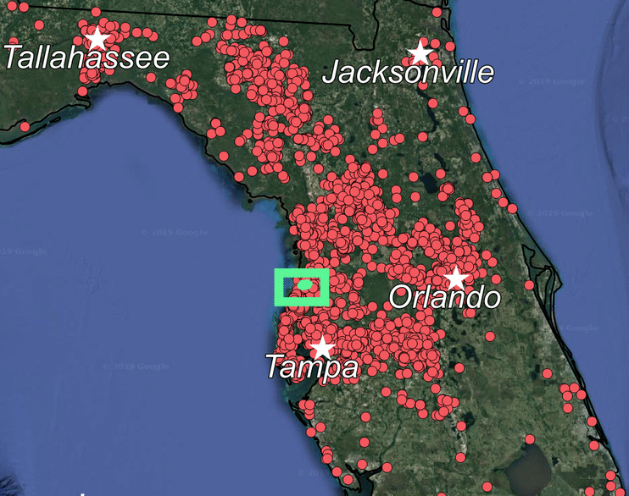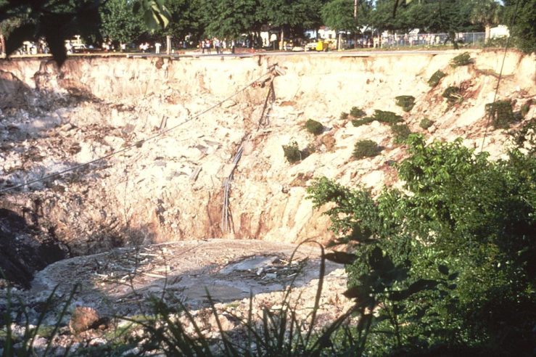
Picture of a Florida sinkhole. With people standing on the side, for scale.
Pre-2015 map of Florida sinkholes. And, they have become MUCH more frequent since then (>400 in 2017-18)

In addition, there are large stretches of America’s coastlines where the buildings don’t even sit on rock, at all; instead, they have been built on sand (often on top of so-called `pilings’, which usually are steel beams, sometimes encased in concrete, that have been driven a dozen yards or more down into the sand). Here's a picture which proves – still in the realm of hard fact – that a house can indeed be built directly on sand, on a beach:
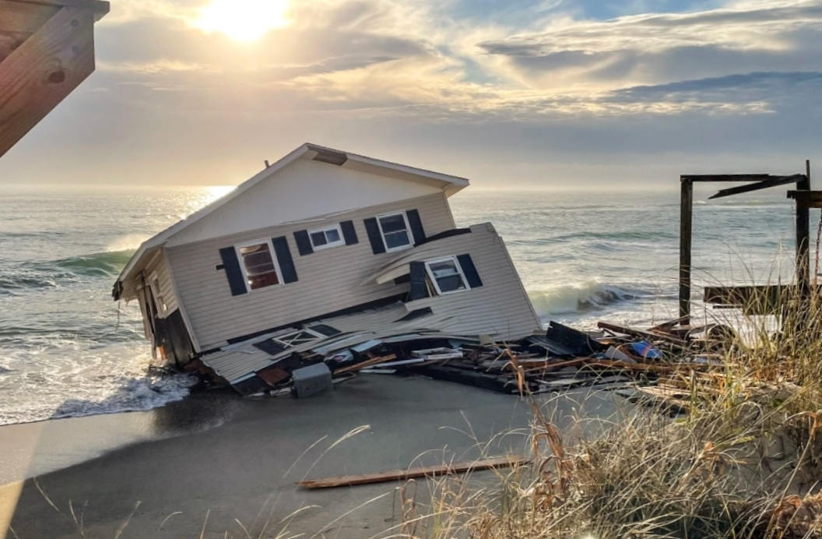
That home was on the “Outer Banks” islands, off the mainland of North Carolina. Those islands are one of the greatest “second home” destinations anywhere in the world, and they are remarkably beautiful. So, anyone who wants to see those islands really should put it on their bucket list to go there, within the next few years. Because – and THIS is the turning point, between hard facts, as set forth above, and predictions about what is likely to happen, in the future – not all that many years from now, there likely will be more ugly wreckage and debris, from destroyed buildings, than natural beauty and charm. And, one might predict, with both logic and reason, that some of its roads and bridges may no longer be passable. Indeed, for anyone who knows what is actually happening, with sea level rise, it becomes an exercise in melancholy, and sadness, to simply but seriously ponder what the area in the map below (on the coast of North Carolina) will actually look like . . . 20 . . . or 30 . . . or 40 years from now.
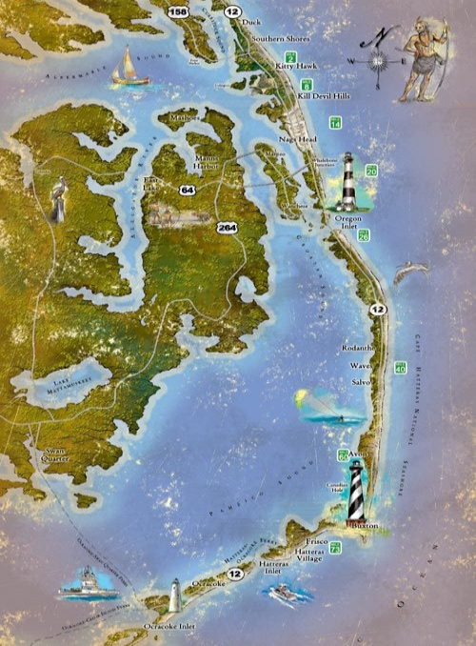
CRUCIAL GLOBAL WARMING FACT #9 (THE LAST ONE)
NEARLY 40% OF THE WORLD POPULATION LIVES IN “COASTAL COMMUNITIES”, WHICH WILL BE THE FIRST AREAS THAT WILL HAVE TO BE ABANDONED, AS SEA LEVELS RISE. THAT’S ABOUT 3 BILLION PEOPLE, LIVING IN “COASTAL COMMUNITIES”
This last and final “Crucial Fact” relates to population densities, along coastlines. For numerous reasons, coastal areas are much more densely populated than “inland” regions. Five major reasons include: (i) direct access to fishing, and food from the ocean; (ii) rich soil for crops, deposited by river deltas over millions of years; (iii) cheap and easy ways to dispose of garbage, sewage, etc.; (iv) easy ways to bathe, which helps reduce insects and pathogens; and, (v) the climate tends to be more pleasant near a large body of water, in any temperate or tropical zone, and even in many cold but sub-arctic zones.
As a result, according to the 2017 UN Conference on Coastlines, about 40% of the entire world population (of humans) lives within about 30 miles (50 kilometers) of a coastline, even though that amount of area is only a small fraction of the earth’s total land surface.
More importantly, when it comes to assessing the threats posed by global warming and sea level rise, the UN Conference adopted the phrase “coastal communities” to help it focus on cities, villages, etc. that are close enough to a specific coastline to be heavily and directly affected by it; and, they determined that 37% of the entire world population lives in what the UN Conference called “coastal communities.”
Since 37% is almost exactly the fraction 3/8 (= 37.5%, to be precise), and since about 7.5 billion people live on this planet, today, NEARLY 3 BILLION PEOPLE, AROUND THE WORLD, LIVE DIRECTLY IN “COASTAL COMMUNITIES”.
I have not found or seen a list of which major cities are classified as “coastal communities” as defined by the UN report, so I do not know whether cities such as Chicago, Detroit, Cleveland, or Toronto (on the coasts of the Great Lakes), or cities such as Philadelphia, Houston, and New Orleans (all at low elevations, only a few miles away from salt water) are included. However, even a brief mental review can remind anyone that most of the largest and most populous cities in the US (including New York City, Boston, Baltimore, Miami, New Orleans, Los Angeles, the entire San Francisco bay area, and the entire Seattle area) are all directly on salt-water coasts, and in other countries, nearly all of the most populous cities (including Tokyo, Shanghai, Hong Kong, Singapore, Sydney, Mumbai (India), Karachi (Pakistan), and Lagos (Nigeria)) are all directly on salt-water coasts.
In addition, anyone trying to understand what sea level rise will actually do, to literally billions of people, should take a look at this satellite picture of the Nile River delta, in Egypt, and think about what it shows, and means:
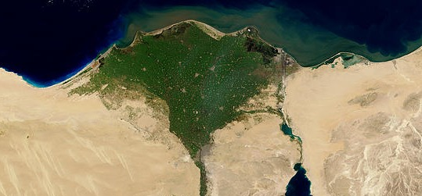
The city of Cairo – with multiple millions of people – sits mainly on the bottom third of that green triangle. And, because of how river deltas are formed (i.e., by silt and sediment dropping out, once the rate of flow of a river slows down, as it approaches the ocean), river deltas are always wide, and flat, with very low elevations.
So, HERE is the transition point, in this Fact #9, between hard facts, as set forth above, and predictions about what is going to happen, in the coming years. If anyone wants to argue that any prediction set forth below, on the remaining part of this page, is illogical, merely speculative, and not strongly supported by both facts and reason, then they should explain why, and set forth their own predictions, to be judged – fairly and honestly – as the years go by, as people see what actually happens.
Since river deltas are wide, and flat, and have low elevations (that much is fact, arising from how river deltas are formed), then, therefore, if sea levels rise by more than a foot, over just the coming 40 years (as they are predicted to do), the zone of damage, in the Nile delta, will not merely be a narrow strip of land, adjacent to the Mediterranean Sea. Instead, the salt water will push inland, into and across the wide, flat, low-elevation land that was created by slowly-settling sediment. The entire delta – and, the entire city of Cairo, even though it is not normally considered a "coastal community" by most people – is going to be in severe jeopardy.
In addition, and equally important, ALL of the agricultural area that appears in green, in the photograph above, is likely to be flooded – recurringly, for a while, and then parts of it will be continuously flooded, after that – by salt water. And, salt water is very, VERY bad – `deadly' probably would be a better word – for the types of "crop plants" that must devote large amounts of energy, nutrients, and metabolites, in growing what is – for humans – the `food' part of the plant. Some types of weeds can grow reasonably well, in salty or `brackish' water (i.e., water with lower levels of salt than sea water); however, "crop plants" cannot, since they already are being pushed, pressured, and stressed – hard – to spend so much of their resources, growing their `food' parts. So, the amount of crop plants, and food, which the Nile delta will be able to support and grow – which keeps literally millions of people alive, in cities like Cairo (and, in nearly every OTHER large city which is on or near a major river delta, anywhere in the world) – is going to be severely damaged, if not outright destroyed, just within the next few decades.
The people living, not just next to the coasts, but in any and all low-lying areas near coastlines, will be severely and unavoidably affected, by sea level rise caused by global warming.
And – returning to a `hard fact' as set forth above – there aren’t just a few hundred million of them. Instead, there are THREE BILLION of them. As stated above, nearly 40% of the entire world population lives in "coastal communities."
As a result, HUGE numbers of people will be, quite literally, FORCED out of their homes (and livelihoods) in “coastal communities”, as those homes and communities become – in words that are both blunt and true, and yet, somehow, evasive and euphemistic at the same time – “no longer habitable.”
When that happens, they will have no choice but to TRY to somehow move themselves, and their children and families, “inland”.
And, as that happens, the following “predictions” will be seen, not as predictions, but as inevitable and unavoidable results, as surely as the prediction that if something heavy is thrown up into the air, it will fall back down to earth, on that very same day! The direct results of the disasters and catastrophes that will begin happening, when sea levels begin rising at the accelerated rates that this planet is heading toward, seem likely (read: unavoidably, and inevitably) to include each and all of the following:
(a) The people being forced to leave “coastal communities” will be severely and even desperately hungry – if not during the first few days after they have left their homes, then, most certainly, within a few days after that;
(b) Nearly all of them will be broke, with no savings whatever, since whatever they owned, while living on the coast, has been destroyed; and,
(c) They will be very, VERY angry, and embittered, at losing their homes. Indeed, most of them will be quite convinced, in advance, that no matter where they might try to settle, they will be met with deadly resistance and violence; and, therefore, the only way to have even a chance to survive, in some hostile “inland” area, is by meeting (or, better yet, by anticipating) such violence, with violence of their own.
Okay, then. Desperately hungry; forced out of their homes; broke; angry; and, ready to commit violence, and even to kill, when necessary. It’s difficult to think of a more effective combination, if the goal is to start not just one war, but dozens of wars, all at the same time.
The Navy prefers to describe global warming and sea-level rise as a “catalyst for conflict”, and it’s not hard to figure out why they would choose the word ‘catalyst’. Very few Congressmen know what a catalyst actually is, but nearly all of them have some type of vague recollection of having heard the word (usually from a high school or freshman chemistry course, decades earlier), and they are vaguely aware that a `catalyst' can speed things up; so, they can nod their heads (and even mumble agreement, when appropriate) in ways that can make them appear knowing, and agreeable, when they hear a phrase like “catalyst for conflict”.
But, in reality, one of the requirements for something to actually be a “catalyst” is that it cannot be consumed, or altered, by the chemical reaction which it catalyzes. And, it is hard to imagine anything not being “consumed”, when desperately hungry, broke, and angry people are forced out of their homes along a coastline, and are forced to march inward, and are forced to begin fighting and killing people who will – vigorously, and emphatically – not want to share anything with the . . . not just waves, but tsunamis . . . of refugees fleeing coasts that are “no longer habitable”.
That situation will not be “a catalyst for conflict”; it will be a “recipe for disaster”. It would be more accurate and realistic to describe it as, “a runaway train with three billion passengers on it, hurtling at high speed, toward a cliff”, than to pretend – with politeness, diplomacy, and restraint – that, “well, yes, some of those types of conflicts might be catalyzed, and speeded up a bit, by those types of conditions.”
So . . . since the U.S. Navy knows what is happening, and can predict (with pretty good accuracy) what is going to happen next . . . taxpayers and voters need to begin asking, and insisting – and even demanding, if necessary – that the Navy should move past and beyond its historical desire to not confront and antagonize any Congressmen. If its officers and enlisted men truly want to serve America, defend democracy, and preserve our Constitutional form of government, they need to “tack” (a sailing term), and change course, and begin telling Congress – immediately, and in clear and even blunt and harsh terms – the painful and even horrible truth about what they expect to happen, as sea levels continue to rise (except, at even FASTER rates), in the ways that the Navy knows – perfectly well – are already happening.
This marks the end of the “CRUCIAL GLOBAL WARMING FACTS” (nine, in all). So, this is a turning point. The things on the following pages are predictions, and do not claim or pretend to be facts.
And, yet, even though the very nature and essence of science says that it cannot claim or pretend to “prove” anything which has not yet happened . . . science is, nevertheless, VERY good at making predictions.
Before the actual predictions are set out, the next page explains how the terms “proof” and “prediction” are used in very, VERY different ways, by scientists (who want knowledge, and truth) versus politicians (who want power and control, even if they have to tell lies to get it).

TWO PREDICTIONS:
THE FUTURE OF FLORIDA

As noted at the end of the prior page, this page offers predictions about the future, rather than known facts.
But first, I need to point out a severe misalignment, between: (i) how scientists think, work, and communicate; versus, (ii) how politicians distort, manipulate, and scheme. That misalignment has helped lead us into a dark tunnel, which we can no longer get out of, while a runaway world-threatening train of disasters is coming at us, hard and fast.
As one who has been practicing law – and, observing and listening to politicians – for more than 40 years, I’ve had plenty of exposure to the ways most lawyers and politicians learn (and are taught, trained, motivated, and pushed), not to remain steadfast and faithful to some abstract concept of ‘truth’, but to use skill, cleverness, manipulation, and sometimes distortion -- and sometimes, even outright dishonesty (but – the rest of the world can hope – only when truly necessary) -- to create arguments and claims that will help some lawyer or politician get the result(s) he wants. I’m not claiming scientists are saintly in comparison, or are always and forever honest; nevertheless, they live in a different world, and are held to different standards, which lead to large and important differences in how they talk and work, compared to lawyers and politicians. As two major points of difference:
PRINCIPLE #1: SCIENTISTS ARE TAUGHT AND TRAINED TO NEVER CLAIM TO KNOW ABSOLUTE TRUTH
Good scientists learn that they are risking (and jeopardizing, and threatening to damage, and possibly even destroy) things they do not need to risk, if they ever, ever claim to know ‘absolute truth’ about anything scientific.
Part of that attitude comes from their objections and resentment over how humanity has been controlled and manipulated, for so many centuries, by selfish, conniving, manipulative people who, throughout history, have claimed divine right, divine inspiration, divine power, and anything else divine, which they claimed had been given to them – directly, and personally – by and from God. Since scientists know how much those attitudes held back good science, they don’t want to be accused of doing the same things, themselves.
There are, regrettably, a few not-so-good scientists who claim things such as ‘Evolution has proved that there is no God,’ but those people are in a small minority, and any non-scientists should try to accept, tolerate, and understand that those types of statements should be regarded as evening- and night-time statements of non-scientific dogma, and personal opinions, from outliers who actually work as scientists only during their day jobs, and who (apparently, if they make severely dogmatic and unscientific statements in public) never really managed to figure out what good science is, and what its limits are. Alternately, people should simply recognize and accept that a VERY small (but prominent) number of scientists have figured out how to make money, by selling atheism, as a product. As an example, when Richard Dawkins goes out on book tours, to promote his latest book encouraging everyone to be an atheist, he charges $1500/hour, to sit with and give reassurances to those who might be wavering, and afraid of some version of Judgment Day, after they die. His website openly advertises that price, for a 1-hour session with him.
Another part of the modest attitude (among good scientists) about needlessly and foolishly risky claims to ‘absolute knowledge’ comes from seeing, a number of times, how some set of widely-accepted “knowledge” had to be heavily rewritten and revised, in light of later discoveries. As one example, the very definition of “atom,” for roughly 2000 years, had been ‘the smallest possible component of mass’. However, major discoveries in the late 1800s and early 1900s forced scientists to realize and accept that, ‘No, that prior belief was wrong, because now we know that atoms actually are made up of even smaller components, which we now call protons, electrons, and neutrons.’
And then, it even happened again (!!), with yet ANOTHER major re-write, and shake-up. Starting in the 1960’s, scientists realized that even protons, electrons, and neutrons are made up of even smaller components, generally called quarks (with additional terms such as hadrons, baryons, muons, bosons, etc.).
BOTH of those two major transitions – BOTH of which cut directly to absolutely fundamental, center-of-everything questions, such as, ‘What is matter, itself? And, what are WE made of?’ – played a powerful and enduring role in teaching scientists to NOT claim to know ‘absolute truth.’ Why not? Because, in all truth and seriousness, more information, and alternate theories, may come along that may require major re-writes.
In similar ways, biology and medicine never have been, never will be, and never can be, fully quantifiable, “deterministic”, and predictable. Whenever ANY large biological population is measured for ANY variable trait, the results can be reported accurately, only as statistics and probabilities; the hard data will be arrayed across a ‘bell curve’ shape, and the question becomes, ‘Where does this individual happen to fit, on that type of statistical curve?’ Similarly, doctors simply accept and admit that they will NEVER be able to fully understand (or reliably predict) why some patients with severe and even dire conditions get better and recover, while other patients, having apparently milder conditions, succumb and die.
A third reason why scientists are taught to NOT claim to know ‘absolute truth’ about anything scientific, comes from a mature and insightful realization that the trait (or, even just the appearance) of modesty tends to be pleasing, agreeable, and “becoming”, even if (or, especially if) it comes from some apparently super-human being, with super-human strength, and super-human knowledge and insight. Because good science combines the efforts and accomplishments of so many contributors, it is, indeed:
(i) super-human (i.e., it stretches vastly above and beyond the capabilities of any single human);
(ii) super-humanly strong (i.e., strong enough to move entire mountains, lift giant rockets into space, and then figure out how to kill, with precision, microbes so small they could not even be seen until a bunch of really smart scientists invented electron microscopes); and,
(iii) endowed with super-human knowledge, and insight.
Regarding the not-so-modest phrase, `super-human knowledge, and insight’: science finally became what we regard as ‘science,’ only about 150 years ago. There were so many epochal advances in each and all of chemistry, physics, and biology, between about 1850 and about 1870, that that timespan can fairly be called the beginning of what we recognize, today, as ‘science’. Science then began acquiring, at a HUGE velocity, so much knowledge and insight that – in only about 150 years – it has totally and utterly changed the entire world, all of humanity, and all human civilization. Radio, television, automobiles, airplanes, nuclear power, computers, cellphones, modern medicine, genetics, genetic engineering – the list is endless, and none of those things could have been even imagined, by anyone, in 1850. Those are compelling illustrations, evidence, and “proof” of how intelligent, insightful, and powerful science is, and of how much it has changed society, and humanity.
So, science – and good scientists – have learned to modestly claim and assert that nothing they claim to know, is “absolute truth”. If someone comes forth with a new theory or hypothesis, scientists will not try to have that person arrested, tortured, and then killed because he was spouting blasphemy which can corrupt other scientists if allowed to continue. Instead, any good scientist will respond by saying, “That is an unusual claim, and I will not believe it unless he can provide very good and strong evidence that he is right, and all the rest of us have been wrong. So, what is his evidence? What is he actually saying?” And, the scientific community will ask that person to show them his evidence, whatever it might be.
But now . . . take that principle, and remove the word ‘absolute’ from the phrase, ‘absolute truth’? How much does that change the meaning of ‘truth’? ‘Truth’ is the noun, the thing, itself. Adding an adjective doesn’t really change what the thing, itself, actually is.
So, scientists who try to convince (and warn) politicians about global warming, do not really feel comfortable in saying what ‘science’ does and does not >> KNOW << to be >> TRUE!! << Instead, they must begin using complex, cluttered, difficult-to-understand charts and numbers, about statistics and probabilities.
And . . . THAT . . . is where scheming politicians – who want power, more than anything else, including truth – find gaps, openings, opportunities, and excuses to attack and highlight any candid and honest admissions, about the limits of what good science does, and claims.
THAT severe and even tragic misalignment – between science, versus political scheming and conniving – is where politicians find the opportunities and excuses they can use to simply ignore and criticize the warnings they get, from scientists. The tragic blind spot of too many scientists is that they will sacrifice themselves, and what they are trying to do, by continuing to do their level best to always be scrupulously and carefully honest, even when they are being cut up, and cut into pieces, by dishonest and unscrupulous knife-fighters who have knives in their hands, and malice in their hearts.
PRINCIPLE #2: GOOD SCIENCE DOES NOT AND CANNOT “PROVE” ANYTHING WHICH HAS NOT YET HAPPENED; INSTEAD, IT CAN ONLY MAKE PREDICTIONS, AND FORECASTS, ABOUT THINGS THAT HAVE NOT YET HAPPENED.
​ Another severe misalignment, between how scientists communicate – versus how politicians claim, strut, posture, parade, bloviate, and argue – arises from the fact that science never claims to have “proved” anything which still lies in the future, and has not yet happened. Instead, science modestly accepts, understands, and says that any statements about the future are merely predictions (or, forecasts, extrapolations, or similar terms).
However, that does NOT means that “predictions” are puny, uncertain, unreliable, and a poor substitute for truth and knowledge. Instead, people should recognize and respect GOOD predictions as having – and providing humans with – enough courage, foresight, motivation and energy to actually get things done. Predictions about what will happen, that day, are what enable, motivate, and drive the kinds of people who will actually accomplish things, to get up every morning. Predictions about what will happen, in the future, are what enable companies to do business.
To understand that point, consider the following: every type of manufacturing operation that is ever performed, by any person or company, anywhere in the world, rests entirely and totally on predictions. Plain and simple. A chemical manufacturing process rests on predictions which say, in effect, “I hereby predict – and, I have bet good money on this prediction – that if I put these chemicals, in the quantities and temperatures listed on this page, into this machine, and if I provide power to the machine, and turn it on once it has been loaded with those chemicals . . . well, I predict that this machine will convert these chemicals, into the product I want to make.”
If some process involves mechanics rather than chemistry, the prediction will require only minor changes, without changing its nature or meaning: “I hereby predict – and, I have bet good money on this prediction – that if I put this piece of sheet metal into this machine, then this machine will shape this piece of metal into a car fender, which will then have a shape which will enable us to fit that fender onto the type of car we are making in this factory, today.”
That is the very essence, and the key, to understanding what manufacturing actually is, and does, and accomplishes. Being able to successfully and accurately PREDICT things like that, is what enables ALL manufacturing operations. It is what enables ANY company to pay for the machines that will do the predicted operations, and to pay for the supplies and materials which must be loaded into those machines, to enable them to work. Rather than being puny, uncertain, or unreliable, predictions that are skilled, shrewd, intelligent, and insightful, are absolutely crucial, critical, essential components of any and all decisions and commitments which enable things to actually get done.
Clearly, some types of predictions are so obvious and predictable that it can seem silly or stupid to even make them. Simple example: I hereby predict that, no matter WHAT day, or week, or month, or year, you happen to read this . . . the next morning after that, the sun will seem to rise over the eastern horizon, rather than the western horizon. Why? Because of the scientific rules of momentum, and inertia; there is NO reason to expect that the earth will suddenly stop rotating in the same direction (or speed) that it has been rotating in, for billions of years.
Now, here is the crucial point which needs to be made, and understood, about that type of prediction: no matter how obvious a prediction might be, it still is only a prediction, if it describes something which is expected to happen, but has not yet happened. Science – no matter how powerful or insightful it is – simply cannot “prove” something which has not yet happened, and cannot happen until some time in the future. Even something as obvious as claiming and stating, with total certainty, that the sun will rise in the east, tomorrow, is not proof; it is a prediction.
As another example, I can safely and reliably predict – with absolute, total, 100.0000% confidence (and with as many zeroes after the decimal point as anyone might care to imagine) that if I lift up something heavy, and heave it upward, on any day next week, it will fall back down to earth . . . on the very same day!! Why? Because that’s how gravity works. But even so – and here is the crucial point – IF I have not yet DONE it . . . then I have not yet PROVED it. I have only PREDICTED it.
That is the nature of science, and the problem becomes this: the words and the terms that science uses, to discuss and describe things that have not yet happened, can be seized upon, hijacked, and used in very different ways, by politicians who do NOT want to have to face up to troubling, difficult, frightening warnings. Republicans who do not want to have to vote for large and expensive programs to help slow down global warming, have an easy and obvious excuse. Using the exact same words that the scientists are using, Republicans act as though, and talk as though, and claim that, all they need to say, to justify their actions to voters they regard as their ‘base’, is ‘The scientists have NOT even PROVED that those things are going to happen.’
Somehow or another, people who want to protect the planet need to find ways to cut through that tactic used by politicians (especially Republicans, plus Joe Manchin in the Senate).
My suggestion and proposal is this: the most promising, high-potential, and best chance that we have, to cut through the stalling and word-game tactics that too many politicians use to avoid facing up to real, serious, and even horrible threats coming at us because of global warming, is by adopting and using this tactic:
(i) make a single, targeted, limited prediction, which focuses on a single specific area, and which sounds so unsettling, dramatic, disruptive, and almost bizarre, that it begins gathering enough attention, and headlines, to force people to begin taking sides on whether or not they think that prediction is valid, reasonable, and likely to be true; and, then,
(ii) bring in some genuine experts, to begin describing and explaining, in detail, what they believe and anticipate about that prediction, and what they think the time frame will be.
In my assessment, Florida is the best focal point, for predictions that may be able to shake things up, to a point where more people will begin to seriously ask and think about the predictions and arguments on both sides, and about which side is being more honest.
And, in my assessment, that needs to be done urgently. This year. BEFORE election day, November 2022. Why so urgent? Simple – so that voters can make better-informed choices about which candidates they should vote for, for Congress, in 2022.
So – as someone who has studied environmental science, and who actually understands the actual facts about global warming that are described on the prior pages, here is what I offer, as a serious, genuine, sincere prediction about ‘The Future of Florida’:

PREDICTION #1: The Future of Florida
Based on my work, studies, and level of understanding as an environmental scientist and engineer, I hereby predict that, within less than 35 years (with 2022 as the first of those 35 years), the coastal regions of Florida will be rendered more than 90% unlivable, by sea level rise. Property values along the Florida coast – which amount to trillions of dollars in 2022 values – will drop by somewhere in the range of 95-98%, within less than 35 years (probably within less than 30 years, or even just 20 years), as people are forced to witness and reckon with the unmistakable and unstoppable onslaught, once the damage truly begins and then accelerates. Within 40 years, nearly all homes and apartments along the Atlantic coast of Florida will have to be abandoned (Florida’s Gulf coast likely will follow, within about 10 years or less, after that); and, at least 10 million people (out of a current population of about 22 million) will be forced into ‘refugee’ status, driven northward and/or inland, having no significant savings or assets beyond a car (or possibly two), and whatever they are able to carry in that car (or two). The only people who will remain behind will be radical outliers, outlaws, and ‘frontiersmen’ who choose to live lifestyles that are completely and totally different from ‘normal’ Americans. Rather than paying rent or taxes, the people who remain in Florida, or who move to Florida willingly, will defy any and all outside authorities, and will challenge anyone to come and take any rent or tax money from them, if they think they can. Violent gangs will form, as a substitute for severely broken (or totally abandoned) government and law enforcement services, and their members will claim to be pioneers who are performing valuable services for America, and for all countries, by figuring out, and showing everyone else, how some type of semi-functional remnant society can be organized, and managed, in the areas that previously were coastlines. In addition, at some point in the process, people will begin bombing and destroying bridges or other “choke-points” on the major north-south highways (or, they will attack and disable trucks and cars on those highways, to create barriers to travel without damaging the roads themselves), thereby rendering those highways unable to carry more refugees. This might be done by violent gangs that intend to remain in Florida, in order to give them more valuable items they can plunder and steal; or, it might be done by people who do not want their states, north of Florida, to have to absorb – and begin taking care of, and begin paying the huge costs of taking care of – millions of broke, hungry, unwanted, and very, very angry and embittered refugees from Florida.
Okay, then. Without wanting to seem sarcastic or flippant about the disasters that are coming to Florida, I hope the above is unsettling and disturbing enough to provoke various people (such as reporters, talk radio hosts, TV hosts, debate moderators, etc.) to at least begin asking, `Is this real? Is this serious? Does anyone else, other than THAT guy, think things like these might actually HAPPEN, in real life?’ And then, when experts who genuinely understand global warming begin standing up and saying, `Not only is it possible, it is actually becoming probable,’ then THAT added weight and momentum will become `the tipping point’ which will be enough to enable, and push forward, a serious and ongoing dialogue (and, hopefully, a set of Congressional hearings), about what is going to happen, to Florida, over the coming decades.
This is, indeed, a direct plea for Congress to hold at least SOME hearings, on global warming, during 2022, so that voters can make better-informed decisions, when they must cast their votes for Congress. In addition to directly addressing `The Future of Florida’, the second page after this one proposes several other specific topics for such hearings, which should begin to be at least asked about, considered, and discussed seriously, among members of Congress in both parties.
Regardless of whether Congress decides to hold any such hearings this year, I hereby ask, invite, welcome, and urge any climate expert – or any military officer (especially from the U.S. Navy) – anywhere in the world, to step up and state, as your first and opening comment about the prediction above, where you stand, in terms of your opinions about the time frames set forth above, for “The Future of Florida”. That will help any moderators of any such discussions figure out where to position and classify you, along the spectrum of advocates for an entire range of positions and beliefs, as follows:
(1) Anyone who says it will happen even faster than the timetable above, can be initially placed in an “alarmist” category.
(2) Anyone who says it will NEVER happen, can be placed in a “total denial” category.
(3) And, my suggestion would be that anyone who says something like, ‘Guesses about time frames are not that important, because the prediction itself is horrible, and yet realistic, to a point that deserves serious consideration without getting too distracted by guesses about probable timing,’ should be placed into some sort of “moderate” category.
PREDICTION #2: The Failures of Congress
Unless something truly remarkable happens, during the pre-chaos period – i.e., before the fate of Florida is fully recognized as both catastrophic, and no longer avoidable, triggering hundreds of thousands of ‘refugees from Florida’ to abandon their homes and begin fleeing northward – Congress will show itself to be utterly incapable of facing up to either: (i) the impending disasters and catastrophes in Florida; or, (ii) the challenge of how to respond to the Florida disasters, in any way which will even remotely merit any words of approval or praise (such as ‘squarely’, ‘honestly’, ‘usefully’, ‘effectively’, etc.). The particulars of how (and just how severely) Congress will prove itself to be incapable of meeting that challenge – and other challenges which also will begin growing exponentially, during that same period – cannot be predicted, and can only unfold in whatever way they will. Nevertheless, any American who has observed the failures and dysfunctionality of Congress – even BEFORE a relentless series of coastal crises, in Florida, begin to forcibly PROVE how severe they will be – can safely predict that Congress will NOT be able to create any sort of orderly, logical, or respectable transition process . . . unless something truly remarkable happens, during the pre-chaos period.
Okay, then. So much for the fully serious, on-the-table, cast-my-lot predictions. As a potentially amusing show for the sidelines, which may be able to help focus more (and/or, more sustained) attention to, and questions about, what will be happening in Florida, the next page proposes a ‘betting pool’, comparable to the office ‘betting pools’ that pop up when a Super Bowl or NCAA Basketball tournament is approaching.
The one I propose, on the next page, is called ‘The Mar-a-Lago Pool Pool.’
That name is somewhat tongue-in-cheek, but only in part. The other part is entirely – even deadly – serious.

BETTING POOLS RE: SEA LEVEL RISE:
THE MAR-A-LAGO POOL POOL
In view of the nine facts set forth in this section, I have made fully-confident predictions that: (i) the entire state of Florida is going to be "catastrophically damaged", by a combination of sea level, and limestone collapse, over the coming decades; and, (ii) it will happen much faster than any politicians (especially Republican politicians) are willing to admit.
Therefore, on the NEXT page, I ask and plead with climate experts, young people, and any candidates for Congress who are willing to actually face up to the challenges of global warming, to join in a set of calls, pleas, and demands, for Congress to hold a set of hearings, DURING 2022, to help voters develop and establish a higher and better level of awareness, about what is truly going to happen to the U.S. over the coming decades, because of global warming and sea-level rise. And, at least some of those hearings should begin to seriously ask two deadly serious questions:
(1) What should America do, AFTER an entire state has been lost, and destroyed, and no longer has any functioning government? (2) What should America (and Congress, and the federal government) do, during the period when it realizes that we are indeed losing and destroying an entire state, but the worst catastrophes have not yet happened, and there is still time to take various steps which, in medicine, are called `palliative' or `ameliorative' (usually, by making a patient more comfortable, and giving him/her the time, setting, and support to help him/her come to terms with death, while it is still approaching, before it arrives)?
Meanwhile, instead of just waiting for Congress to do something, private citizens can begin creating their own events, to call attention to the problems that too many members of Congress are determined to ignore. And, here is a proposal which – if it gets started – might end up getting serious attention and publicity, and might turn into an ideal fund-raising opportunity, for environmentally-oriented not-for-profit organizations.
The proposal is to invite and encourage people to begin creating Mar-A-Lago Pool Pools among themselves. These would be betting pools, modeled after the betting pools that pop up in offices and other places, inviting people to place bets of a few dollars each, on things like the NCAA basketball tournament, or the likely score of an upcoming Super Bowl. In any such pool, the people running the pool can set any rules they want, and anyone who joins will wager some fixed amount, to “buy” some particular square, in an array which shows numerous possible outcomes. The “kitty” (or pot, award money, or whatever the organizers choose to call it) goes to whoever was smart or lucky enough to buy the square with the winning guess/prediction.
In a “Mar-A-Lago Pool Pool” (as envisioned herein) anyone can buy a ticket which will correspond to a particular calendar year, starting about 3 years out, and going out as far as the members of that “Mar-A-Lago Pool Pool” wish to extend it (I would recommend limiting it to perhaps 30, 35, or 40 years, and allow any Trump supporters or climate deniers who want to claim and argue that the whole thing is bogus, to buy the entire block of years after the last year covered by some particular pool, for a price such as 3x or 5x the cost of any single year).
The question, which will determine the winner of any particular Mar-A-Lago Pool Pool, will be:
“In which calendar year will the swimming pool at Trump’s Mar-A-Lago resort, on the Florida coast, be submerged by salt water, either `continuously’ (defined below), or on three or more occasions during a single calendar year?”
So . . . if you want to get into some local version of THAT pool, choose a year, and place a bet on it. My preference would be to require bets of at least $10 each, and no more than $10,000 each (among the wealthy).
The terms of any such “betting pool” will need to be defined better, to make them clear enough to be enforceable. I would propose that a “continuous” submergence be defined as, “for at least 30 consecutive calendar days and nights, without interruption”. And, if Trump (or his “successor”, and, yes, I notice and appreciate the irony in that word, since we are talking about someone who might buy or inherit a bunch of coastal properties, just in time to watch them be flooded and destroyed) builds any levees, walls or other water-retaining devices around the Mar-A-Lago pool – or, if he either closes it, or moves it to a different location, to try to minimize the embarrassment of having a high-profile event prove him wrong – then any submergence event(s) will be deemed to occur, if they would have occurred except for the attempted evasion (i.e., if the Mar-A-Lago pool had been left in the same location and condition that existed in 2022). And, if the pool (or some portion of it, large enough to drain the water out of it) is swallowed up or severely damaged by a sinkhole, then THAT will become the `winning' year.
If anyone gets that type of betting pool up and running – with a total time span of at least 25 years, to make the amount of award money at least somewhat interesting and appealing – I would be willing to bet up to $1000, if I can choose one of the years 2029, 2030, or 2031, because that time span is my best guess as to when it will actually happen. I will not choose more than one of those years; I will accept any one of those three years, if the other two are already taken; and, I think no one should be allowed to place bets on two or more years, unless the chosen years are separated by at least 3 or 4 years between them.
So . . . the real point of that type of betting pool, is to get people to begin thinking and talking about, “Do you think it could happen, within just the next 3 or 4 years? Or, do you think it’s likely to take something like 20 to 30 years?”
To me, that does indeed seem to be the REAL question. THAT is the very real question that people (including voters, and Congressmen) should begin focusing on, and wrestling with. So, I would love to see several hundred “betting pools” as described above, pop up, around the country, and perhaps in Congress, as well. In addition, rather than excluding any experts or agencies (such as NOAA, the National Oceanic and Atmospheric Admin.), I think we should, instead, encourage them to get actively involved, and give the people employed at any such agencies a chance to express their opinions, by making their own bets.
I am entirely willing to join the first Mar-A-Lago Pool Pool that anyone gets started with 10 or more bettors, with $1000 for each bet, if I can have a year in the range of 2029-2031, as stated above. In addition, I’m entirely willing to join up to 10 more betting pools as well, with $100 in each, so long as I can choose, and bet on, a year in the range from 2029 through 2033.
And, to help get them started, I would propose that if a pool is organized by some charitable organization, the amount of award money will be only some fixed percentage (such as 50%, 60%, or 70%) of the total money that is wagered, while the sponsoring charitable organization gets to keep the remainder (and, it can take its portion, as soon as the betting money arrives, in cash). That could turn these betting pools into fund-raisers, and could help get more attention and publicity, for those organizations.
I’m not trying to organize these pools, and I will not take any money from any of them (as a “founder’s fee” or whatever) unless I place a valid wager which wins some particular pool, fair and square.
In complete seriousness, the goal of what might look like a light-hearted proposal (at least to some; to others, it might look mean-spirited, and if they come at me with complaints, I will respond with a few well-chosen questions, for them), is to encourage more people to begin thinking – seriously – about a huge and horrible question: “What is really going to happen, in Florida, over the coming years?”
If dozens or hundreds (or even thousands) of “Mar-A-Lago Pool Pools” can get more people thinking seriously about THAT question, they might be able to do some genuine and actual good.
In complete seriousness, it is NOT a question of WHETHER America is going to watch the state of Florida wrecked, destroyed, and submerged, by rising oceans. It is only a question of WHEN.
To some, one of the more interesting corollary questions will become, “Will Donald Trump, Jeb Bush, and George Bush Junior, still be around, long enough to have to watch it actually happen?”
And, to still others, another question which may be worth asking, in advance, is this:
Jared and Ivanka (Trump) Kushner have invested millions of dollars to build a home in a hyper-exclusive gated enclave, on an island called Indian Creek Island, which is in the northern part of Biscayne Bay, across from Miami. What are they going to say – PUBLICLY – when that expensive home of theirs gets so badly damaged that they must move out of it, to somewhere on higher ground (which, by then, likely will not be in Florida)?
In complete seriousness . . . they are public personas, and any really good PR firm should be able to “game out” the five or ten most likely things that Ivanka and Jared will say to the public, when THEY lose THEIR expensive new home, because they were so foolish, and so short-sighted, that they ignored ALL the warnings, and moved to . . . MIAMI (!!!), of all places!!
When their new home in Miami gets destroyed, will they apologize, for doing so little to help deal with global warming and sea level rise, when THEY were in the White House? And, if so, will it be a sincere apology, with genuine sorrow and regret? Or, will it be a dismissive, turn-away apology, which more-or-less says and means, `I already said I’m sorry, so just leave me alone, and go to hell . . .'’?
Or, as a third alternative, will they be stubborn, and defiant, and begin lashing out at others? And, if so, in which ways and directions, and against whom?
In complete seriousness, I would genuinely like to hear what any PR firms, and any political insiders, advisers, and commentators might offer up, as their genuine best guesses and predictions, as to what Jared and Ivanka will actually say, in any public announcements or answers to interview questions, when THEY get hammered and hurt, and have to watch THEIR home being destroyed, the same way so many OTHER people also are going to get hammered and hurt, and have to watch THEIR homes being destroyed.

Plea for Congressional Hearings on Global Warming
>> DURING 2022 ! ! ! <<
​
​In addition to trying to help voters get ready to ask clear, informative, difficult-to-sidestep questions of candidates in races they will be voting on, I would plead with anyone who cares about global warming to begin calling for Congressional hearings about it, THIS YEAR, DURING THIS ELECTION CYCLE.
Why the urgency? Why THIS YEAR?
Answer #1: because the problems and threats are dire, urgent, and time-dependent.
Answer #2: so that voters will better understand the relevant facts, information, and predictions, when they decide who to vote for, in November.
Answer #3: most polls say that Democrats are likely to lose their majorities in both houses of Congress, in the 2022 elections. If that happens, they will lose the ability to call hearings, and to control what will be discussed at any such hearings. They can eliminate that risk, and force some direly-needed information to be placed squarely on the table, face-up, by simply scheduling hearings before the election.
The list below contains my suggestions, for topics that should be raised during the first batch of any such hearings.
The next page, in this website, contains several additional potential topics, but those get into issues such as justice, fairness, and accountability, which can be argued about forever, without ever accomplishing anything worthwhile. As such, they need to be actively and firmly set off to one side, so that they cannot become the things that the worst wrong-doers will seize upon, to further try to cloud and confuse the issues and questions of what needs to be done, now. They are included herein, because justice, fairness, and accountability are indeed supporting pillars of any decent and civilized society, and those on the wrong, parasitic, predatory, destructive side should be encouraged to ponder – starting now – how they, and their legacies, memories, properties, and offspring, are going to be treated, not by those in power now, but by either: (i) those who will be in power 20, 40, and 60 years from now, if indeed there are any such people; or, (ii) angry and violent mobs, who will indeed be seeking justice, but in forms that will focus heavily on revenge, rather than fairness.
QUESTION SET #1:
What are the official positions of the highest-level officers and top strategic planners in THE UNITED STATES NAVY, on sea level rise – including past numbers, current numbers, and projections into the future (with info on levels of confidence)? In specific:
(A) Is it true that, when all the world's oceans are taken into account, worldwide ocean levels rose by an average of 8 inches, during the 100 year span, between 1917, and 2017? To briefly explain that time span, American naval bases began to be heavily rebuilt in 1917, to get ready for World War I, and to help the Navy move away from coal-powered steam engines, to diesel engines; and, by 1917, the technology had developed to a point where experts could accurately calculate sea level averages despite the fluctuations caused by tides and storms.
(B) Is it true that the U.S. Navy also expects average worldwide ocean levels to rise by another 14 inches, in JUST THE NEXT FORTY YEARS? And, if so, WHY is the Navy expecting THAT to happen?
(C) Who, in Congress, has the U.S. Navy been telling these numbers, and these warnings, to, over the past 10 or 20 years? Did ANY of those Congressmen or Senators indicate an actual understanding and grasp of those numbers, and what they mean? And, which members of Congress seemed to have the BEST understanding and grasp of the facts, problems, and threats lurking in those numbers?
QUESTION SET #2 (to be asked of military experts, in this area):
2A. Is it true that essentially ALL of the top planners, strategic analysts, and computer modelers, throughout ALL branches of the U.S. military, have reached a point where they now ALL believe, anticipate, expect, and predict, that climate change will become the single largest and most important factor, in America's international relations, and in triggering outright wars at dozens of locations, all around the globe? And, if it is not true that ALL of them agree with that statement, what is your best estimate of the percentages that do?
2B. Do they believe that the border with Mexico needs to be fortified to a point where it can be defended – by military actions, which will need to include ‘shoot to kill' orders – in order to prevent hundreds of thousands (or even millions) of "heat refugees" from trying to move north, from Mexico and Central America, to escape from temperatures so high that they will be "rapidly lethal" to millions of people over 50 years old, in their countries? And, in what year did each branch of the military first begin to create computer models, and war-game scenarios, which began to weave in those types of predictions, as elements which had, say, a 30%, or 40%, or higher level of probability?
2C. What are your assessments of books that have been published with "climate changes will lead to wars" warnings, such as Climate Wars: The Fight for Survival as the World Overheats (G. Dyer, 2010), and Climate Wars: What People Will Be Killed For in the 21st Century (H. Welzer, 2015)? Which book do you believe is the single best and most informative book on this subject, for citizens and voters who are actively concerned, but who are not experts in the underlying studies, facts, and factors?
QUESTION SET #3:
What do the Chief OPERATING Officers (COO's) of any Fortune 500 companies which have large and important outdoor operations say, and predict, about what they and their companies are thinking and doing, to get ready for global warming and climate change? And, ask the same question of the COO's of the 50 largest home and business insurers. Do ANY of those Chief OPERATING Officers – as in, even a single one? – simply dismiss and ignore the warnings from scientists, about changes in climate or sea levels, because they think it's all a hoax, as President Trump declared when he was in office? How many of those COOs still say that they think Trump was right, on that subject, now that Trump is no longer in office, and cannot direct the Executive Branch of the federal government to threaten or pressure their companies to remain silent, and passive, on that issue? How many are NOW willing to openly and publicly state (regardless of what they might have said while Trump was still in power) that they NOW think that Trump was badly wrong, badly misinformed, and badly misguided, on that subject? And, what do the COO's of home and business insurance companies predict is likely to happen, over the coming 10 years, to insurance premiums on buildings located in "coastal communities", as that term has come to be used?
QUESTION SET #4:
What do genuine and serious experts -- both civilian and military -- say and predict about "The Future of Florida"? What is their best assessment, as of now, of what is most likely to happen between now and 2100, and of the time frames which seem possible, and probable, for escalating damage caused by combinations of sea-level rise, and sinkholes? Do they foresee millions of refugees being forced to flee northward, from Florida, needing entirely new homes on higher ground? Do they believe that, between now and 2100, America will have to watch as an entire state becomes so badly battered, submerged, and destabilized that it no longer will be able to support "normal" government and civil society, with police and fire departments, utility companies which can provide public services, etc.?
​QUESTION SET #5:
What are the best, most useful, most helpful things that America can begin doing, now, to prepare for the onslaught?
As just one example, should we create some sort of "Coastal Transition Financial Agency", to try to help coastal residents not be simply left broke and penniless, when storm surges and waves begin tearing down their houses? Or, should an agency such as that be empowered to provide stopgap measures, as insurance companies decide to abandon, en masse, the coastal regions? Should we consider, for example, a clear and understood transition period lasting several years, where yearly insurance premiums for houses and other buildings will stop, and that money will be placed, instead, into some type of ‘cushion-the-blow' fund? Are there things like building codes and zoning ordinances which, if adopted and used, might be able to help places along the coast extend their ‘useful life' by at least a few years?
And, should Congress consider creating "utility companies for rebuilding", similar to other types of utility companies which provide things like electric power, natural gas, drinking water, and sewage removal. For those have never studied the structure of utility companies, or who might benefit from a brief "refresher" summary, the laws which control utility companies evolved in ways which put them at controlled mid-points, to guard the public against the risks of abuse that can arise from pure capitalism at one end of the spectrum, and outright socialism at the other end. They are privately owned, and profitable, and they issue dividends to their investors; however, the rates they are allowed to charge, and major investments they wish to make, must be approved by rate-setting commissions, which were created by state laws, and which are designed to protect the public. They offer excellent examples of the pragmatic, problem-solving, deal-making, willing to compromise, balance-seeking approach to governing, which did so much to make America stable, prosperous, and powerful, for decades. That type of “bargain, negotiate, find compromises and balance-points, and find approaches and solutions that can actually work” approach has been severely damaged, and has been pushed so far away from the playing field, it is no longer even on the sidelines; instead, the “culture warriors” who can get re-elected by keeping their base of voters angry and unhappy, have forcibly shoved the “bargain, negotiate, and find workable compromises” approach out to where it is now beyond and behind the bleacher seats, where it can't even be seen from the playing field, and where any requests and pleas for reason and moderation are distant enough, and muted enough, to be safely ignored by those who only want to focus on getting re-elected. However, citizens and voters can at least hope that the massive disasters coming at us, due to global warming and climate change, might force Congress to shift back into a problem-solving mode, rather than its current "attack, criticize, refuse to compromise, and hammer any and all hot buttons, as hard as possible, and as often as possible" mode.
So, Question #5, above, can be rephrased as follows: what would experts in finance, engineering, and ‘financial engineering' recommend, as the best ways for America to at least try to begin preparing for an unending and relentless series of climate-related disasters?
QUESTION SET #6:
Should America create some type of "public service period" which would either (i) require, or, (ii) enable and incentivize, people who have never spent any time in some sort of “public service”, to spend a year or so, working on projects that would serve the public good . . . such as, for example, helping clean up and rebuild towns and villages that have been devastated by flooding, fires, tornadoes, or hurricanes?
To help put that question into better focus, below are some pictures of neighborhoods that were devastated, in recent years, by tornadoes, fires, and hurricanes. And, here is a crucial, critical, absolutely essential point, about tornadoes, fires, and hurricanes: ALL of those types of disasters will continue to grow stronger, more severe, and more dangerous and deadly, as the atmosphere and oceans all continue to grow warmer, year after year.
No one really knows, and no can reliably-and-precisely guess or predict, just how much worse these types of warming-driven disasters will get, and how fast the rates of acceleration and increase will be, between now and any arbitrary cut-off year, such as, ‘Over the next 50 years’, or, ‘Between now and 2100’.
Nevertheless, EVERY serious climate scientist KNOWS that each and all of those three types of disasters – tornadoes, fires, and hurricanes – are firmly, totally, squarely, and undeniably in a category which can be briefly summarized as, “As our climate and oceans continue to get warmer and warmer, these types of disasters will not only get worse and worse, they also will become more and more frequent.”
The simple fact is that both hurricanes, and tornadoes, convert heat energy, into mechanical energy. Therefore, as more and more heat energy continues to be piled up, endlessly higher and higher, in the clouds, water, humidity, and air that ‘feed and fuel’ either a hurricane or tornado, then that hurricane or tornado will have more energy that it must somehow “throw off, and turn into mechanical energy.” Similarly, does any serious person doubt, or dispute, that if the atmosphere gets hotter and hotter, it will tend to breed, promote, and contribute to more fires, and larger fires?
And so, the pictures below need to be seen, not as ‘terrible disasters’, but as ‘merely the entryway, to a series of even larger, worse, and even more terrible, destructive, and horrific disasters than these’. Please try to keep a basic, straight-forward scientific truth, principle, and entirely reliable and inevitable prediction in mind, as you ponder the levels of damage that are already being caused by these types of disasters. The scientific truth – the entirely knowable and reliable prediction – can be stated as follows: “These types of disasters will only get worse, and then worse, and then even worse than that, starting now, and going into the future.”
That is a basic, baseline, starting-point realization, insight, and guiding principle. And now, here is where the “disaster levels” already stand, before they begin getting even worse:
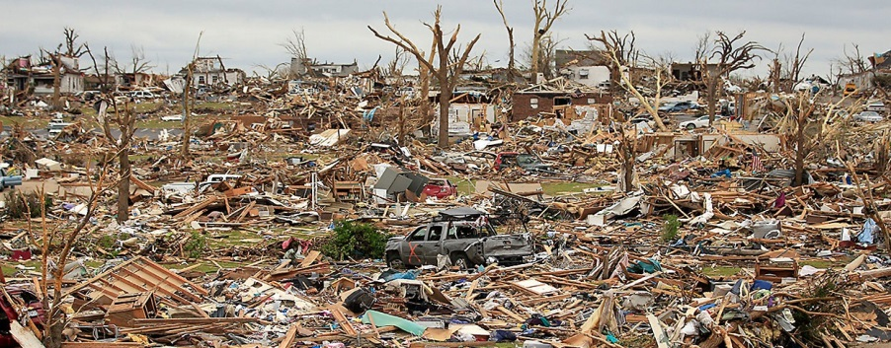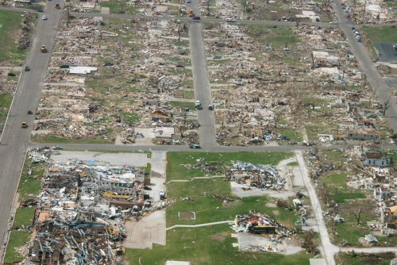
Aerial view of tornado damage, May 2011, Joplin, Missouri
Ground-level view of tornado damage. Unsure whether this was from May 2011 in Joplin, Missouri, or December 2021 in Kentucky.

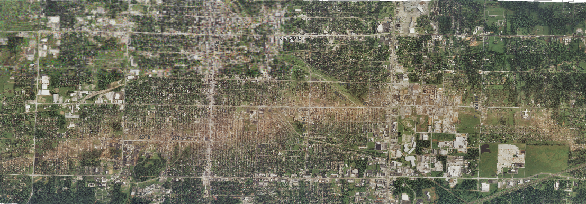
The tornado track in Joplin, Missouri, May 2011. The sandy-brown arc, from left to right (west to east), is where the tornado pretty much scraped and leveled everything except the flat roads, and house foundations made of flat concrete, down to dirt.

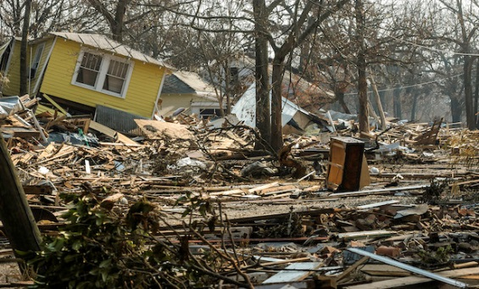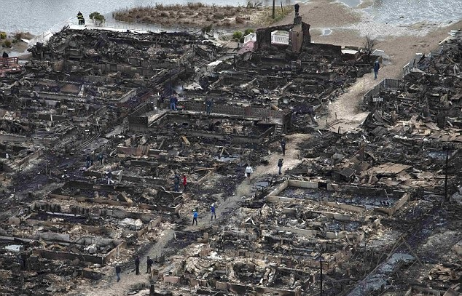
Damage in New York City (Breezy Point, Queens), Hurricane Sandy October 2012
Damage on Gulf coast from Hurricane Katrina, August 2005

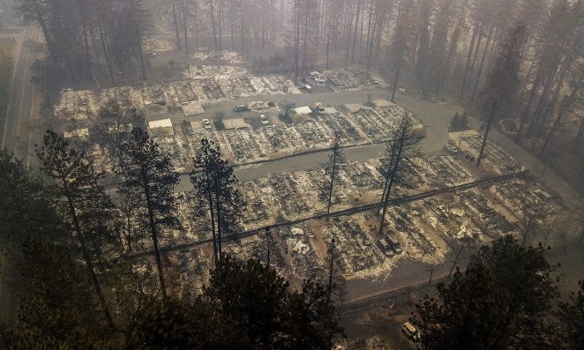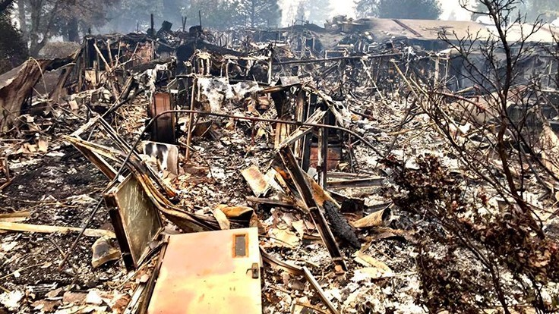
Aerial view of “Camp Fire” (aka Paradise Fire), northern California, November 2018
Ground view of Camp (aka Paradise) Fire, northern California, November 2018

In complete seriousness: "What WILL America do, and what CAN America do, to try to get ready to rebuild, not just a few, but multiple dozens of towns, cities, and neighborhoods which have been damaged as badly as the neighborhoods shown in the pictures above?" That is an absolutely (and even deadly) serious question. Every voter – and every member of Congress – who has enough brains and courage to actually THINK, should try to answer THAT question, before turning and dancing away from hard facts and reality, and grabbing onto some belief or position that seems to offer more comfort and reassurance, in the short term.
One proposal, which I am putting on the table, face-up, can be summarized as follows:
1. We need to begin seriously considering some type of “Public Service Corps”, which can provide hundreds of thousands and possibly millions of people, to help do the repair and rebuilding work that will become necessary, here in America, as disasters such as major fires, severe hurricanes, and monster tornadoes become both more frequent, and more severe, due to global warming.
2. It will take YEARS to actually develop, organize, plan, and create any sort of large-scale program such as this, before it can get started, for real. ANYONE who chooses to support it – and, anyone who chooses to oppose it – must simply yet fully recognize and accept that fact, and talk and behave accordingly. NO ONE should begin screaming and yelling things like, "We need to do this, NOW!!" THAT type of screaming and yelling can be, and will be, attacked, belittled, criticized, and dismissed by the powers-that-be, as ‘unreasoning hysteria’ and worse. So, we need to approach this subject, and discuss and debate it, more calmly, diligently, maturely, and professionally.
3. Instead of putting people into just one type of assignment for a year, the assignments should be shifted, every 2-3 months, to give people training and experience in a variety of useful, practical skills. Any team of skilled civil engineers could list at least 8 or 10 different types of work that people (especially recent graduates of high school or college) could be exposed to, all of which would be practical and useful in helping keep towns, cities, and societies functional, livable, and able to recover more rapidly from a disaster.
4. My own personal belief is that every American – regardless of age – who has NOT previously served in the military, should be “incentivized” to become involved, as a way of ‘pitching in’ and helping their fellow Americans, their communities, their states, and their society, form of government, and civilization. Clearly, different types of tasks will be involved, for people of different ages; and yet, even someone who is, for example, 70 years old, can show up at a community kitchen and help prepare and serve meals to people doing other public-service work, or can help monitor, contribute to, and improve the quality of work and care that are being performed at day-care centers.
5. In addition, anyone working on a project such as this should seriously study the concept of `well-regulated militias’. The first clause of the Second Amendment says those are `necessary’ for the `security’ of a free nation. In the 1600s and 1700s (i.e., the 200-year period which set the stage for the drafting and adoption of the U.S. Constitution), all settlers in or near a `frontier’ area had to be able to defend themselves – immediately, and effectively -- against any type of attack. Such attacks came often, from Native Americans who were trying to defend their land (they usually were called `Indians’ by settlers, presumably to imply that the Indians were the true interlopers, from VERY-FAR-away lands, while Europeans had a better and more true right to occupy the continent), and from French soldiers (who wanted France to be more powerful than England, and who actively recruited Native Americans to help them attack English settlers, in not just one normal war, but an entire series of wars, called “The French and Indian Wars”, which lasted for more than 4 generations, i.e., for 75 long years, from 1688 through 1763). Crucially, any settlers needed to be able to defend against any attack immediately, and effectively, without needing any reinforcements, backup soldiers, additional weapons, or other assistance from some other location, since any attack would be long over, before any reinforcements could get to the site of the attack. As a result, the concept and terminology of “militias” evolved into, “able to quickly mount an armed defense, against an attack” – in other words, the functional equivalent of what we still recognize, today, as “volunteer fire departments.” In the same way that “volunteer fire departments” are still recognized and respected, today, as being truly and genuinely benevolent, public-spirited, and well-suited to help protect the buildings in any area which does not have a professional fire department, the term “militias” -- as understood and intended, when written into the Second Amendment -- should receive the same level of genuine and sincere respect.
However, America has wandered severely away from that intended pathway, to a point where, today, the term `militia’ tends to imply something more along the lines of, “a bunch of right-wing gun-nuts who like to shoot lots of guns, drink lots of beer and whiskey, and talk a lot about how true patriots, like them, should overthrow the government, if Democrats try to take control, because those horrible evil commie socialist Democrats are trying to destroy America, The Land Which Used To Be Free.” In complete seriousness, it is doubtful that most current and sitting members of Congress could accurately describe what the word “militia” -- as used in the Constitution -- even means; and, I cordially invite any and all voters to test that theory, by asking any and all candidates, for either house of Congress, during the 2022 election cycle, to explain, either to an audience, or to a camera and microphone, what the word “militia” actually meant, when inserted into The Second Amendment.
Somehow, we need to get back to the insight, experience, wisdom, and understanding of both human history and human nature which led the Founding Fathers to clearly, directly, and unequivocally insert the following phrase directly into our Constitution, as the single most clear, direct, and plain warning, exhortation, and statement of plain, blunt, honest fact and truth, which appears anywhere in the Constitution:
A well regulated Militia [is] necessary to the security of a FREE State.
One last comment also merits serious attention. The fact is that dozens, and dozens, and dozens of communities are going to be hit by natural disasters, increasing in both frequency and intensity, in the coming years. In any human patient who has suffered a heart attack, the physicians absolutely MUST do EVERYTHING THEY CAN, to preserve and protect whatever level of “residual functioning” can be provided by the still-beating but damaged heart. In a directly analogous way, if a community has been badly damaged by a major disaster, whatever “residual functioning” it still has, absolutely MUST be protected, in order to enable it to recover, and be rebuilt, MUCH more quickly and effectively, in ways which can serve its residents. Accordingly, any serious discussion of “well regulated militias” should focus -- first and foremost, in a manner comparable to stepping cautiously and prudently on the first rung of an old, unused, and potentially dangerous ladder, or the first stair in an old and potentially dangerous staircase – on what it would take to create numerous local organizations which can strongly, STRONGLY discourage looting, thievery, rioting, and other bad acts, at a scene where an initial disaster has rendered some location suddenly and highly vulnerable to even more damage, which -- in the absence of a “well regulated militia” – will be created, intentionally and maliciously, by people who will do the equivalent of attacking that community. THAT is one of the first, foremost, and absolutely most important things that anyone who wants to help form, or join, a “well regulated militia” can aim for, work toward, and try to help create.
And, lest anyone accuse me of being some sort of gun-nut, I will add that I would propose that anyone, in any such militia, needs to have, and be trained to use -- as a first option, and a first line of defense -- some type of `semi-gun’ which can both: (i) fire something like rubber bullets, darts, or similar projectiles, which can sting, burn, and hurt like hell, but which will not kill or maim; and, (ii) create and store (in ways which cannot be turned off or jiggered) a high-resolution, darkness-adaptable video of anything or any person which is shot, by that `semi-gun.’
I also want to make a direct statement and commitment that I’m not just trying to foist off a bunch of work, onto other people. If this project gets started, I would be entirely willing to work in it, as a standard-level worker. Instead of resenting the idea of having to help other people, I’ll simply pass on an observation, by a wise physician, that one of the best and most effective ways to make oneself feel better, is by looking outward, reaching outward, and helping someone who needs help. Frankly, I suspect that many of the worst internet trolls and haters are people who are trying to fight off the unhappy nagging realization that they, themselves, have done depressingly little to ever help anyone who really needed it. Unhappy people tend to think, mistakenly, that if they can somehow offload and unload some of their unhappiness onto someone else, then they can make that other person carry it for them, and they’ll have a lighter load, with less weight. Life, happiness, and a sense of accomplishment and fulfillment really don’t work that way, but people need to actually reach and experience a point where they can experience, for themselves, how much better it feels to actually help people who need help, than to spend an entire lifetime trying to repeatedly push loads of bitterness, anger, frustration, and unhappiness onto the shoulders and heads of others.
A great deal more can, should, and will be said, about this, as the need for it becomes more and more pressing, then urgent, and then dire. My goal, in bringing it up now, is to try to help get it added to the mix – sooner, rather than later – during discussions and debates over how America should try to deal with climate change, so that we can start moving – sooner, rather than later – in a direction we will need to move in, some day, as the disasters grow even worse.​

POTENTIAL TOPICS FOR HEARINGS, ABOUT ISSUES OF TRUTH, JUSTICE, FAIRNESS, RESPONSIBILITY & ACCOUNTABILITY

Recognize from the outset: Debates about abstract concepts can never be won, or solved, so they cannot be allowed to entangle, stall, or prevent practical & effective responses to climate change.

The previous page sets forth questions which may indeed have actual, practical answers, and which may help point Congress (and voters) toward better-informed and better responses, to climate change.
By contrast, the questions below are on issues that relate to more abstract concepts, principles, and ideals. These types of arguments can be argued endlessly, especially if clients with money are paying teams of lawyers and lobbyists to keep generating and injecting endlessly more arguments into a debate or proceeding, for as long as possible, with the goal of stalling and delaying any genuine and effective response which might reduce short-term profits or hinder some other goal a client has. Therefore, abstract topics must be controlled, limited, and guarded against, in order to create actual, useful, helpful and productive responses to a problem.
Therefore, the goal of including these topics, in a list of potential hearing topics, is to add the warning set forth above, to anyone who is tempted to go wandering off on digressions and detours suggested by one or more of these topics. The optimal solution might be to put them on the table, give the “paid deniers” a fair chance to commit themselves even more deeply -- in an official record, under sworn oath -- to the harm and the evil they are doing, then firmly move on, and allow things like “justice” and “fairness” to take their own time, follow their own course, and eventually circle back to the wrong-doers.
And, as that happens, over a span that will take decades to play out, perhaps the best form of justice that can be achieved, over the short run, is to firmly plant, in their minds, some form of constant, gnawing, corrosive fear. Based on everything I have learned about human nature, human history, human greed, and human psychology, from practicing law over the past 40 years, I would suggest that perhaps – just perhaps – the single best way to deal with such people, and to persuade them that they really should change course, now, and at least TRY to atone for at least SOME of the evil and damage they have done, is by planting in their minds a seed which can grow with the power of truth, logic, and reality. The truth which they will NOT want to hear, and NOT have to think about, in the darkness, night after night, as they try to go to sleep, is this:
The wealth, prestige, and power they gathered – by damaging this planet so badly that hundreds of millions of innocent people will have to die horrible deaths – is NOT going to keep them safe, or comfortable, or protected. It is NOT going to make them (or their children, or grandchildren) happy and secure. Instead, that wealth – and the stories, rumors, and whispers that will follow that wealth, wherever it goes –will become a curse. Rather than making those people – i.e., the ones who made more money, by knowingly, intentionally, and greedily making global warming even worse than it otherwise would have been – safe, protected, or comfortable . . . the wealth they managed to gather, by doing evil, is only going to turn them (and their children, and grandchildren) into bigger, fatter, wealthier, and more tempting targets.

QUESTION SET #7:
If Congressional hearings are held this year (2022), they would offer an excellent opportunity to get sworn testimony – under oath, and on the official record – about climate change, by both:
(i) actual and genuine experts, in climate science; and,
(ii) some “client change deniers”. I prefer to call them “paid disrupters”, since they have been paid big bucks, by various companies and individuals, to do anything possible (e.g., cynical and manipulative half-truths, loudly insisting that trivial matters were truly important, etc.) to stall, delay, thwart, and hold off any effective actions to reduce CO2 emissions, for as long as possible, since each and every year of delay will bring in more profits to the companies and donors that are paying the ‘paid disrupters’. I would even raise the question as to whether it would be proper and appropriate to call them "mouth-whores". I don't think I will do so, myself, but it raises a sufficiently interesting question that I might defend the right of anyone else to begin openly and publicly calling them that, in ways that they will hear, and have to listen to, and have to try to answer.
Witnesses from both groups – the experts, and the paid disrupters – should be asked to describe, in detail, under oath, what their current positions are, and why they have those positions, now that they’ve had time and opportunity to evaluate recent events (such as the droughts and wildfires in the west, the monster tornados of the past few years, and any or all of the nine sets of facts described on the preceding pages).
Any committee which is holding such hearings should keep any paid disrupter sitting at the witness table, where he (that is not meant to be sexist, but ‘paid disrupters’ are almost always men, presumably because nearly all women have more powerful instincts to care, to feel compassion, to help nurture things, etc.) will be required to listen (and, out of fairness, be allowed to respond), while a genuine expert dissects, dismantles, and disproves whatever some ‘paid disrupter’ just finished trying to claim, argue, spew, and pretend.
If that type of hearing is held, the committee(s) could also ask a few people such as Lee Raymond, and Charles Koch, to appear before them, and testify, under oath, about what they did, and how they feel about it, now that they have had more time to see the actual results of global warming. For those who might not recognize the names, Lee Raymond – while the CEO of Exxon – did more than anyone else, ever in history, to fund “research” and “scientists,” if they would promise to try to create doubts about climate change (even though Exxon’s own internal documents showed that the officers of Exxon knew, even then, that it was very real, and very serious).
And, Charles Koch, and his brother David (Koch is pronounced as ‘coke”, so they are usually called “The Coke Brothers”, using either spelling) gave out hundreds of millions of dollars, to Republican candidates (always and only Republicans), but only if those candidates would swear eternal fealty, loyalty, and submission, to the false pretense that global warming was just a hoax. And, lest anyone jump to the conclusion that they were so successful and wealthy because they were brilliant, courageous, daring visionaries who could see into the future . . . well, the fact is, they became wealthy and powerful, by simply inheriting a petrochemical company, which their father had already created, and had built into a major success. David has passed away, but Charles is still alive, and is now trying to distance himself from what he did, back then, to (and with) those politicians he funded. So, it would be appropriate to now give him a full and fair chance to describe, explain, and defend – openly, in public, and while under oath – what he did, and how he now feels about it, now that he has had time to see what the actual effects of his (and his brother’s) past actions are turning into.
QUESTION SET #8:
Is there any solid evidence which should be aired publicly, which would indicate that Donald Trump’s actions, when President, were “unduly” affected by the number and the value – TO HIM, PERSONALLY – of the coastal properties that he and/or his companies or children own? Clearly, if he is asked that question while NOT under oath, his answer will be, ‘No.’ However, valid and legitimate questions can (and, in the opinions of many, should) be raised, about things like, ‘What part – in absolute numbers, and in fractions or percentages – of his fortune consists of properties that are on or near coastlines? Trump Tower, in New York City; the Mar-a-Lago estate, on the Florida coast; and, the Trump golf course in Scotland, are all near coastlines, and those are just three examples. How many coastal properties does he actually own? How much are they worth, to him, and to his companies and/or children? Is there any specific evidence that he put their value to him, personally, in a higher category than “the public interest, and what is best for America”?
There are plenty of records of Trump political appointees who deleted, watered down, diluted, and rewrote information – originally written by actual experts – which tried to warn the public and Congress about the damages of sea level rise. Therefore, a question arises which can be stated as: Were ALL of those efforts “legitimate and valid” efforts to serve America, and the public interests? OR . . . were they attempts by groveling sycophants to gain favor with Trump, by protecting and increasing the values of Trump’s private properties and holdings, at the expense of the public interest?
Anyone can argue and speculate about what Trump’s motives and thoughts might have been, when it came to those actions. However, the undeniable fact is that numerous official actions – imposed by political appointees, on agencies and experts that tried to resist – helped prop up and sustain the values of the coastal properties that Trump and his companies (and children) continued to own, while he was President. So, the question becomes: are ANY of those appointees – the ones whose actions did indeed help sustain and increase Trump’s private personal wealth – willing, now, to testify, under oath, about WHY they took (and/or were told to take) those actions? And, are there any emails, on that subject? And, what would Trump, himself, say about it, directly . . . NOT if merely asked about it by a reporter (anyone can guess what the answer to THAT question would be), but if he – plus Ivanka, Don Junior, and Eric – had to answer questions like that, under sworn oath?
QUESTION SET #9:
This final question can be phrased as follows:
At some point in time, if things get so bad that the federal government (and budget) simply cannot respond adequately to all of the environmental disasters that will be happening in different parts of the country, should the amount of federal financial or other aid (including the allocation of National Guard troops, or other disaster-response personnel) that must be divided, distributed, and allocated in some manner, among various states which all have competing needs, be “adjusted” by one or more factors which will indicate or reflect how strongly, consistently, and stubbornly certain states kept sending people to Congress, who did everything possible to BLOCK any sort of useful and realistic action, to help control global warming?
Stated in alternate terms, how should concepts and principles such as accountability, responsibility, and justice be applied, to those who made the problems of global warming even worse, more destructive, more horrible, and more deadly? Should actions which deliberately ignored, mocked, and ridiculed the best scientific advice – for a continuous span of about 40 years, when useful things could and should have been done – become the basis for telling those particular states which aggressively led the fight to NOT do anything useful, things which those states will NOT want to hear? Things along the lines of, ‘We sure are sorry about those mega-tornadoes that tore up your state so bad. But, we have only limited funding left, to help lots of people who have suffered similar problems. And, since your state, in particular, did everything it could to make things even worse, we have decided to release those federal funds, and send these National Guard troops, to states which tried to help reduce, control, and limit the problems, rather than to states like yours, which ignored and mocked and ridiculed all the warnings, and made things even worse.”
Would THAT be a reasonable position, perhaps, for some future Congress to take? Or, some future President?
I’m not saying that it either would or wouldn’t, or should or shouldn’t. Instead, I’m merely predicting that quite a few people will begin to openly ask questions like that, in a few more years, when politicians start pointing fingers and trying to shift the blame in true and deadly seriousness, rather than as mere posturing and electioneering. I’m suggesting that maybe we should anticipate that type of argument in advance, in the hope that we can at least try to get out in front of it, and deal with it rationally and intelligently, rather than letting it trap and paralyze us when it rears its head in real and genuine anger . . . as it someday will.
I will openly admit that my effort to raise this question – at this time, and in this manner – is intended to try to provoke some thought, questions, and concerns, among the citizens and voters of states that have, for decades, consistently elected people to Congress who stubbornly, stupidly, and adamantly did everything they could to ignore, belittle, criticize, and attack every warning, and to block and prevent any effective actions that might have helped slow down global warming. I hope and believe it might become a good thing, if voters in those states are confronted with the unpleasant possibility that some day, perhaps, they might be held accountable for what they did, in ways they will not like, at all, if and when it actually happens, in some future decade.
And, I will openly admit that the implicit suggestion and hope, intended by raising this question at this time, openly and publicly, is that voters in those states should try to begin trying to do better, starting now. By way of analogy, this is like truthfully and honestly telling a life-long smoker that his lungs can at least begin to repair themselves, somewhat, no matter how much damage was done to them in the past, if he will stop smoking, now; and, he should also be told (again, in total honesty), that no matter how much he has smoked in the past, he will indeed be less likely to get lung cancer, or heart disease, if he will stop smoking, now – or even just cut back – rather than continuing to smoke as heavily as before.

FACING UP TO REPUBLICANS
ON CLIMATE CHANGE

In all matters OTHER THAN global warming and sea level rise, I will genuinely, sincerely, and honestly try to stay neutral between the two parties, and will try to help show BOTH parties how they can re-build some bridges between them, if their candidates and/or members in Congress truly want to help ALL American voters, and ALL citizens, and ALL taxpayers, on terms that the majority of voters themselves want (rather than the standard strategy of passing laws that no one outside of that party’s `base’ actually wants, and then proclaiming that those laws are truly what is best, for all Americans).
HOWEVER . . . on the sole and single issue of global warming and sea level rise . . .
For anyone who actually understands how massive, destructive, and deadly the approaching disasters are going to become, it is impossible to stay neutral and balanced, between Democrats and Republicans. On that issue, the sad fact is that Republicans have a terrible, dreadful, shameful record of obstructing any and all efforts to even begin to face up to the horrible (and rapidly increasing) problems our entire nation will soon be facing. That record stretches back continuously, without even a single break, for about 40 years. Even worse, it still has not changed, to this day . . . which, sadly, makes it appear that most Republicans in Congress still have not learned anything at all, about global warming and climate change, during those 40 years, no matter how much the evidence has grown, multiplied, and continued to confirm the warnings (and carry out the predictions) from experts who truly wanted and tried to help.
This isn't saying that Democrats have been perfect, or that there have not been ANY Republicans who have taken responsible stands on this issue.
Nevertheless, if one looks at the history of what Republicans in Congress (as a group) have done, concerning climate change and sea level rise, that record stands solidly and undeniably at:
(i) a flat ZERO, in terms of good, helpful work; and,
(ii) an absolute 100%, in terms of determined and concerted efforts to BLOCK and PREVENT any actually USEFUL actions.
I offer that statement as an open public challenge. If ANY Republican believes it is unfair, then let that person (or group) simply issue a list of all the good things which, in their opinion, `Republicans in Congress’ have actually DONE, to help slow down global warming and sea level rise. A plain, straight-forward, factual list, please, which any voter can see and examine, and which experts can analyze, and respond to.
Unless and until that happens, an analogy might help people better understand what needs to be done, this year, in this election cycle, to begin moving in the right direction.
If you are driving a car through a dangerously hot desert, on a hot afternoon in August, and one of your tires goes flat, you need to fix that flat, as quickly as possible, and then get moving again. It doesn't matter whether your car might also need a tune-up, whether the windshield wipers should be replaced, or anything like that. You need to fix that flat tire, and then get moving again, toward safety, as your highest priority.
In the same way, anyone who cares about global warming – or about coastal property values – needs to focus on the pathological, reckless, and even horrifying refusal of Republicans, in Congress, to face up to the facts of what is actually happening to this planet. THAT is the broken part which is preventing our nation from being able to start doing what needs to be done. Instead of fussing about details, we need to focus on the broken part which absolutely must be fixed, before we can get moving. And, as of now, the broken part is an intransigent and unreasoning refusal by Congressional Republicans to face up to the facts of global warming, and to then begin doing what our nation, and our planet, urgently and even desperately need to have done.
When it comes to the massive and deadly threats that are heading toward us, fast and hard, because of global warming and sea-level rise, people should not try to pretend, somehow, that there is a valid, reasonable, and appropriate way to remain neutral and impartial, between the two parties, on that issue. We need to begin facing up squarely and honestly to hard and even horrible facts; and, that will require courage, rather than neutrality. As many people as can be persuaded to do so, need to look squarely into the faces of Congressional Republicans, and tell them, "Your party has been severely and consistently wrong, on this matter, for the past 40 years. And we are now facing disasters we can no longer prevent, or control, because of how wrong your party has been, for decades. The time has come when Republicans need to change their position, dramatically, on global warming. You need to begin facing facts, and reality, and you need to begin doing what is right. Because, among other things, the voters of America are seeing undeniable facts, and are realizing, in greater and greater numbers, every year, just how severe and threatening the approaching dangers, upheavals, and disasters really are. If the Republican Party continues to refuse to face up to reality, the voters will throw you out, and they will choose others, if necessary, to do what needs to be done."
No matter how many people begin doing things like that, we all need to accept that no single election will create a major change in trajectory, in how Congress begins responding to global warming. Even if the Republican Party undergoes – partly before the 2022 election, and partly after seeing its results – a series of cracks which might someday expand into more (and more serious) acts of conscience, integrity, and true leadership, any number of crusty, cantankerous, stubborn, and unwilling-to-think `oldsters', combined with loud and aggressive `culture warriors', will continue to do anything and everything possible, to try to paint anyone they regard as a rival for power – i.e., anyone who is trying to actually help America get ready for the global warming problems that are coming – as socialists, extremists, far-left-wingers, and radicals. Accordingly, anyone who wants to help, should anticipate that response, and should begin proposing, discussing, and planning ways to overcome that type of opposition.
Along those lines, I'd like to put a proposal on the table, for a bill which might someday be introduced into either chamber of Congress. I’m stopping short of advocating or arguing for adoption and passage of this bill; instead, as an outsider who doesn't claim or pretend to understand the inner workings of Congress, I merely suggest this as a draft of a single clause which might be inserted into some larger bill on climate change.
I will also openly state that the likelihood of any such clause being actually passed, and signed into law, sits pretty much at flat zero, during the first year that something like this might be introduced, as just one small part of some proposed bill to be considered by some committee in Congress.
And yet, I suspect and hope that this proposal, if brought up for serious debate, might be able to help begin, nudge along, and perhaps even `yank loose', the extremely difficult process of trying to `re-orient' some of the thinking about global warming, among Republicans. If they are asked, calmly and seriously, to think about what they would do, if they are put under the same types of jeopardy and threats that they are inflicting upon millions of other Americans, some of them might at least begin to glimpse, and perhaps even consider, the problems they are making worse, from some angle other than an angle of shallow, superficial, unthinking denial.
And, in the years which will follow any such first attempt, the onslaught of environmental disasters will continue to grow worse . . . every year . . . year after year . . . at faster and faster rates, exactly as all the warnings, and all the true scientists, have been predicting, for decades, now.
When horrible real-world disasters begin happening at faster, and faster, and relentlessly faster rates, THAT is when a proposal such as the one above – even though it likely will be dismissed and attacked as being radical, offensive, un-diplomatic, or whatever, the first time or two that it is introduced – can and will begin to seem more and more moderate, and more and more reasonable, and more and more possible, every year. And THAT is the goal. Rather than being dismissed as a half-baked, quirky, quixotic effort that seems doomed to fail, this proposal needs to be seen, instead, as part of a longer and larger strategy. If the right type of seed is planted, in the right place, it can become a tree, within a few years. If Republicans in Congress have to begin worrying about whether THEY might somehow be subjected to the same types and levels of risks, threats, dangers, and damages that they are subjecting millions of OTHER people to . . . well, THAT is when they are most likely to actually begin to change the way they think.
And, if anyone can offer up any alternatives which they think might offer better ways to put serious and substantial pressure on the long-term thinking of Republican Congressmen, or Republican voters, then please, step forward, speak up, and share those ideas with the rest of us.

PROPOSED BILL, CONCERNING THE PENSIONS OF CONGRESSMEN WHO REFUSED TO HELP AMERICA GET READY FOR THE DISASTERS THAT ARE COMING AT US
My first draft of a proposal, for a provision which could be inserted into a larger bill that addresses global warming, could say something along the lines of:
Any member of Congress who has consistently refused to take reasonable steps to face up to the threats of global warming and sea level rise, will henceforth, from the day this law takes effect, have any and all of his/her pension payments invested solely and entirely in coastal properties. Because those members of Congress will have shown and proven, by their actions, that while they were in a position of power and responsibility: (i) they did not believe that global warming posed any real threat to America, of sufficient importance to be worth anticipating or responding to; and, (ii) they felt no sense of duty, while in Congress, to help America prepare for the damages that are now being caused by global warming and sea level rise . . . therefore . . . those members of Congress shall be required, by law, to submit to, and to endure, and to suffer, the same types of hardships they imposed upon over 100 million other Americans. As soon as any such member of Congress leaves Congress, he/she shall be required by law to move to a coastline, and to maintain a single residential home on that coastline, with no second homes or other living arrangements. If subsequent developments prove that the refusals by those former members of Congress -- to face up to reality, or to seriously evaluate and consider the warnings concerning global warming that were consistently offered to them over a span of multiple decades -- were horribly and egregiously mistaken, and showed extremely bad judgment . . . then, as an appropriate penalty for the damage they inflicted on America . . . those former members of Congress will have to watch their own homes be destroyed, and be swept away by rising oceans, as will also be happening to millions of innocent victims of their wrong-doing. If those former members of Congress end up watching their own homes be flooded and washed away, then they are encouraged to contemplate, during those times, that what is happening to them – and to the legacy of what they did, during their time in power – is at least one form of justice, even though it will not be able to help any of the innocent people who are being hurt by the appalling lack of judgment and foresight, and by the recklessly ignorant and destructive acts they committed, while they were members of Congress.
Let me repeat that I have no delusions that any such provision like that is likely to be passed, and signed into law, within the next few years. What I am saying, instead, is that every Republican in Congress should be compelled to realize and accept that such a bill has already been introduced, in Congress, in complete seriousness and sincerity; and, after that step has already been taken once, those accursed Democrats are likely to include similar provisions, in any global warming bill that is ever filed, in every future session of Congress. And, as major disasters (including the total loss and destruction of the entire state of Florida) begin to prove -- beyond doubt or dispute -- how stupid, reckless, and short-sighted the Republicans in Congress were, for deliberately ignoring (for decades) every scientific warning about what was actually happening to our planet . . . well, some day, as the disasters continue to grow even worse, that type of provision, in one of those bills, might actually pass, and become law. And, if and when THAT ever happens . . . well . . .

WHY DEMOCRATS SHOULD SCHEDULE GLOBAL WARMING HEARINGS THIS YEAR, IN 2022
​ Finally, I would point out to any and all Democrats currently in Congress that it is, indeed, VERY MUCH in YOUR best interests, to begin holding hearings on global warming and climate change, NOW – THIS YEAR, WITHOUT DELAY.
There are TWO powerful (and, one would hope, fairly clear and obvious) reasons why:
(1) Voters need to have that information made public, THIS YEAR, so that they can make better-informed decisions, when they must decide who to vote for, this coming November; and,
(2) If the current political polls hold up through Election Day, Democrats in BOTH houses might lose the power to call those types of hearings, AFTER November.
So . . . for BOTH reasons, the Democrats who control both houses of Congress, and who have enough power to call hearings, need to act NOW, rather than waiting until after the November elections.

​

